

**A Proposed System for Makabayan Security Agency**

**168 1st Avenue, Margarita Vill., Bajada, Davao City**

Time/Date of Defense: 4:10-5:10pm/March 02, 2017

**Members:**

Rhyle Abram P. Regodon

Jan Leryc V. Ibalio

Anton John B. Pasigado

**Adviser:**

Fr. Ramon Prudencio S. Toledo, S.J.

**Panelists:**

Jereza, Bernie M.

Cruzado, Kromyko C.

Alviola, Christopher O.

**TABLE OF CONTENTS**

Title Page i

Table of Contents ii

**Chapter I. Introduction**

1. Background and Problem Definition 1
2. System Objectives 3
3. System Benefits 4
4. System Scope 5
5. Glossary 5

**Chapter II. Existing System** 7

1. Data Flow Diagram 7
   1. Level 0 (Context Level) 7
   2. Level 1 8
2. Events List 9
3. Activity Diagram 11

**Chapter III. Proposed System** 12

1. Events Table 12
2. Use-case Models 20
   1. Use-case Diagrams 20
   2. Use-case Specifications 24
3. Sequence Diagrams 75
4. Domain Class Diagram 79
5. Screenshots 81

**Reference** 99

**Appendices** 100

**Chapter 1**

**INTRODUCTION**

**A. Background and Problem Deﬁnition**

A Management Information System (MIS) is a system focused on managing data gathered through different processes such as transactions. It produces fixed, regularly scheduled reports based on the firm’s transaction processing systems (Laudon, 2009). According to Gordon (2016), MIS programs are responsible for managing the records and data of a business including how they are created, archived, retrieved, and disposed. A Management Information System is the platform chosen to propose to the selected firm. The proposed system has features that have more benefit towards the guards. It includes four main modules. The first two modules are systems for the management of guards and clients, that includes application forms, biodata, and an archive for the guards’ details. The third module is for transactions that includes the ability to assign guards to clients, show assignment history of the guards, monthly duty details reports, and the ability to create guard schedules. The fourth module is a flexible payroll system that includes calculations and deductions from store credits, social benefits, and bonds, adding of bonus, and salary report.

Makabayan Security Agency (MSA) was the firm selected by the proponents. According to their agency profile “Makabayan Security Agency, Agency Profile (2016), it provides security contract services to different clients such as government and private institutions. The firm was established on September 30, 1997 and currently being managed by Mrs. Cecilia I. Abude as of December 2017. Located at 168 South Square Corner First Avenue, Margarita Village, Bajada, Davao City, the firm is just 300 meters away from J.P. Laurel Avenue. MSA is currently being manned by experiences licensed security officers and professional personnel that is maintained by the agency. The agency also procures brand new and original low and high-powered firearms for their armaments, three vehicles and three motorcycles for their operational purposes, and radio-based handhelds, telephone lines, and fax machines to render the agency’s service at its best. The mission of the agency is ensuring the safety and security of the people and its client by providing effective and efficient security services. This is in line with their vision which is to attain a peaceful place to work, live, and do business by aiming for a highly professional, credible, and capable agency that can respond to the needs of its client. Behind the scenes are the security guards that risk their lives in order to deliver the agency’s mission and vision.

There is no system currently being installed in the said Agency. All their processes are done manually including their payroll and monthly duty details report. Their guard and client profiles are stacked in hard copy. Finding an available guard that is close in the area is also a hassle since their files are not sorted. Generating lists of the guards assigned is also done manually. Another problem that the agency wanted us to work on is on generating a monthly duty details report that they need to store for reference. They are currently manually typing each report each month. Their current way of working is at risk of losing important data. These difficulties do not just slow their processes; it also halts their work if they cannot find the file they are looking for.

To better expand their capabilities, the proposed MIS was presented to the agency. The system will not only benefit the agency, but the security guards as well. A profile system is also incorporated that keeps track of the guards including their location and whether they are available or not. With this feature, they can easily pinpoint which guard is in the area and available. It includes an automated payroll system that stores, calculates, and formats payroll depending on the client that needs it. An application for bonus and deductions are also incorporated in the transactions system. This payroll system can drastically increase their efficiency in distributing the salary of guards. Because of the manual procedure of making a monthly duty details report, the system will also have an automatic generator of monthly reports via the Assignment and Duty Schedules module.

**B. System Objectives**

The following are the objectives the proposed system must do.

***To make the accessing of guard information faster and more efficient****.* The Guards Management System is the subsystem that handles guard information. The Guard Management System gives the administrators the ability to create, edit, and archive information about their guards. It aims to make the accessing of information faster and more efficient.

***To make the accessing of client information faster and more efficient****.* The Clients management system is the subsystem that handles client information. The Client Management System gives the administrators the ability to create, edit and archive the information of their clients, as well as the ability to generate reports based from the collected data. It aims to make the accessing of information faster and more efficient.

***To make the generation of Monthly Duty Reports and Duty Details faster and less prone to human error***. The Assignments and Duty Schedules Management System is the subsystem that allows the user to manage the schedules and duty detail orders of the guards. This subsystem aims to make the creation of Monthly Duty Reports (MDRs) and Duty Detail Orders (DDOs) faster and less prone to human error. It also makes the process faster than their current procedures of creating MDRs (manual typing, scanning of documents, manual formatting).

***To give the administrator fast and easy access to the payrolls.*** The payroll management system is the subsystem that allows the user to view and modify the payroll of each guard. It aims to make payroll calculations (e.g. MSA guards’ wages, bonuses, and other payments.) automatic and helps drastically reduce the number of human errors committed in processing the payroll.

**C. System Beneﬁts**

The following are the beneficiaries of the proposed system.

***Guards****.* The system will benefit the guards because of the automatic payroll calculations. As said above, it will help drastically reduce the number of human errors committed in processing the payroll. They will therefore have the right amount of money given to them whenever they get paid. The system will also have an easier Benefit Form Application so whenever they would need a loan or cash advance from their salary, they would be able to apply faster and have it processed sooner.

***Manager.*** The system will benefit the manager through the information system. It makes the searching and processing of guards’ information (e.g. Guard name, ID number, Contact Information, etc), faster and more efficient.

***Clerk****.* The system will benefit the clerk because the system will provide biodata and transaction records within the database which will easily be accessed through the search bar. There will no longer be any papers for forms and documents lying inside drawers which will make their processes (e.g. filling up of forms) easier.

***Client or Customer***. The clients will be able to benefit the system because they will be able to hire guards faster. The system will be automated; therefore, the process of hiring will be faster. In an event that they need their guard’s information, it will be given to them by the agency faster through the automated database which contain the information of the guards.

**D. System Scope**

The current implementation is currently limited to intra-agency data flow. The administrators can only access the information in designated computers. The administrators cannot access the information online, as it is limited to a local network.

The guard management system and payroll management system is limited for guards only. They do not include the information and payrolls for regular employees, dissimilar from guards, who are paid per shift. Furthermore, the calculation of payrolls of regular employees follow a more complicated process requiring human intervention. The proponents were advised by the company not to implement the calculation of regular employees’ payroll.

Cash advances range from Php500.00 to Php1000.000, and can be claimed every 8th and 22nd of the month. Cash bonds range from Php100.00 to Php500.00.

This study started November 2016 and will end on October 2017. This study is limited for two semesters and with the knowledge of a second-year college student.

**E. Glossary**

The following are the definitions recorded by the respondents.

***DDO (Duty Detail Order).*** A document issued to a person by the juridical entity or employer wherein the details of the disposition of firearm is spelled-out, thus indicating the name of the guard, the firearm information, the specific duration and location of posting or assignment and the authorized bonded firearm custodian for the juridical entity to whom such firearm is turned over after the lapse of the order.

***Long Certificate of Registration (LCR).*** Refers to a regular license to own and possess firearms issued to government agencies or offices or Government-Owned or Controlled Corporations.

***Cash Bonds.*** An arrangement wherein a guard an amount of money to secure the fulfillment of an obligation. In cases where the guard fails to comply with the obligation, the money is forfeited in favor of the latter.

***Daily Time Report.*** Daily attendance of the guards, submitted by the client to the agency every other week, as basis for the Guard's payroll.

***Monthly Duty Report.*** A report of guard attendances, submitted by the clients to the company, where guard’s attendance is based.

**Chapter 2**

**EXISTING SYSTEM**

1. **Data Flow Diagram**
   1. **Level 0 (Context Level)**

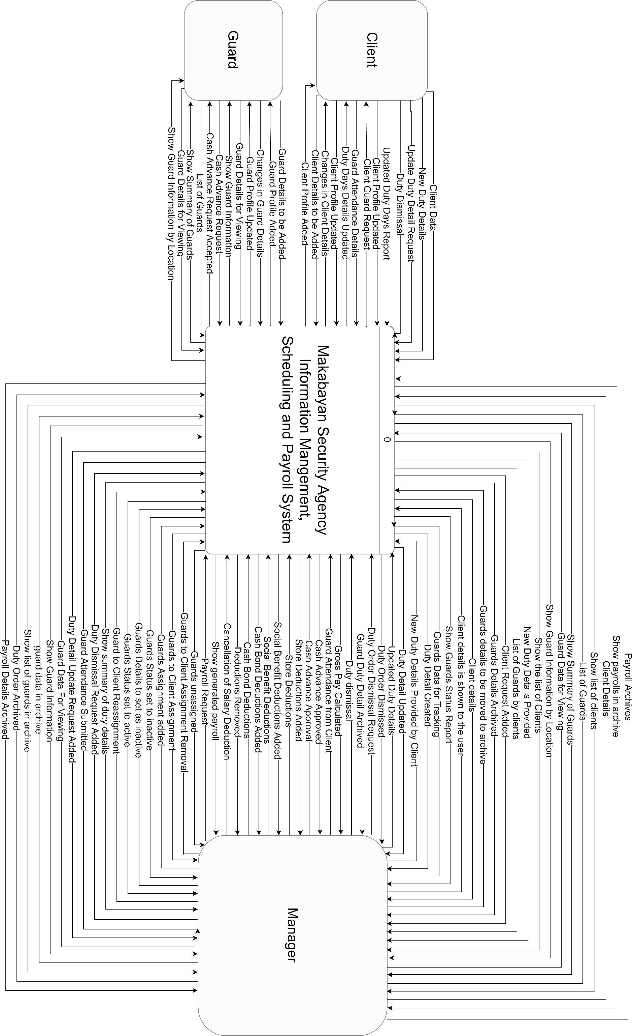

* 1. 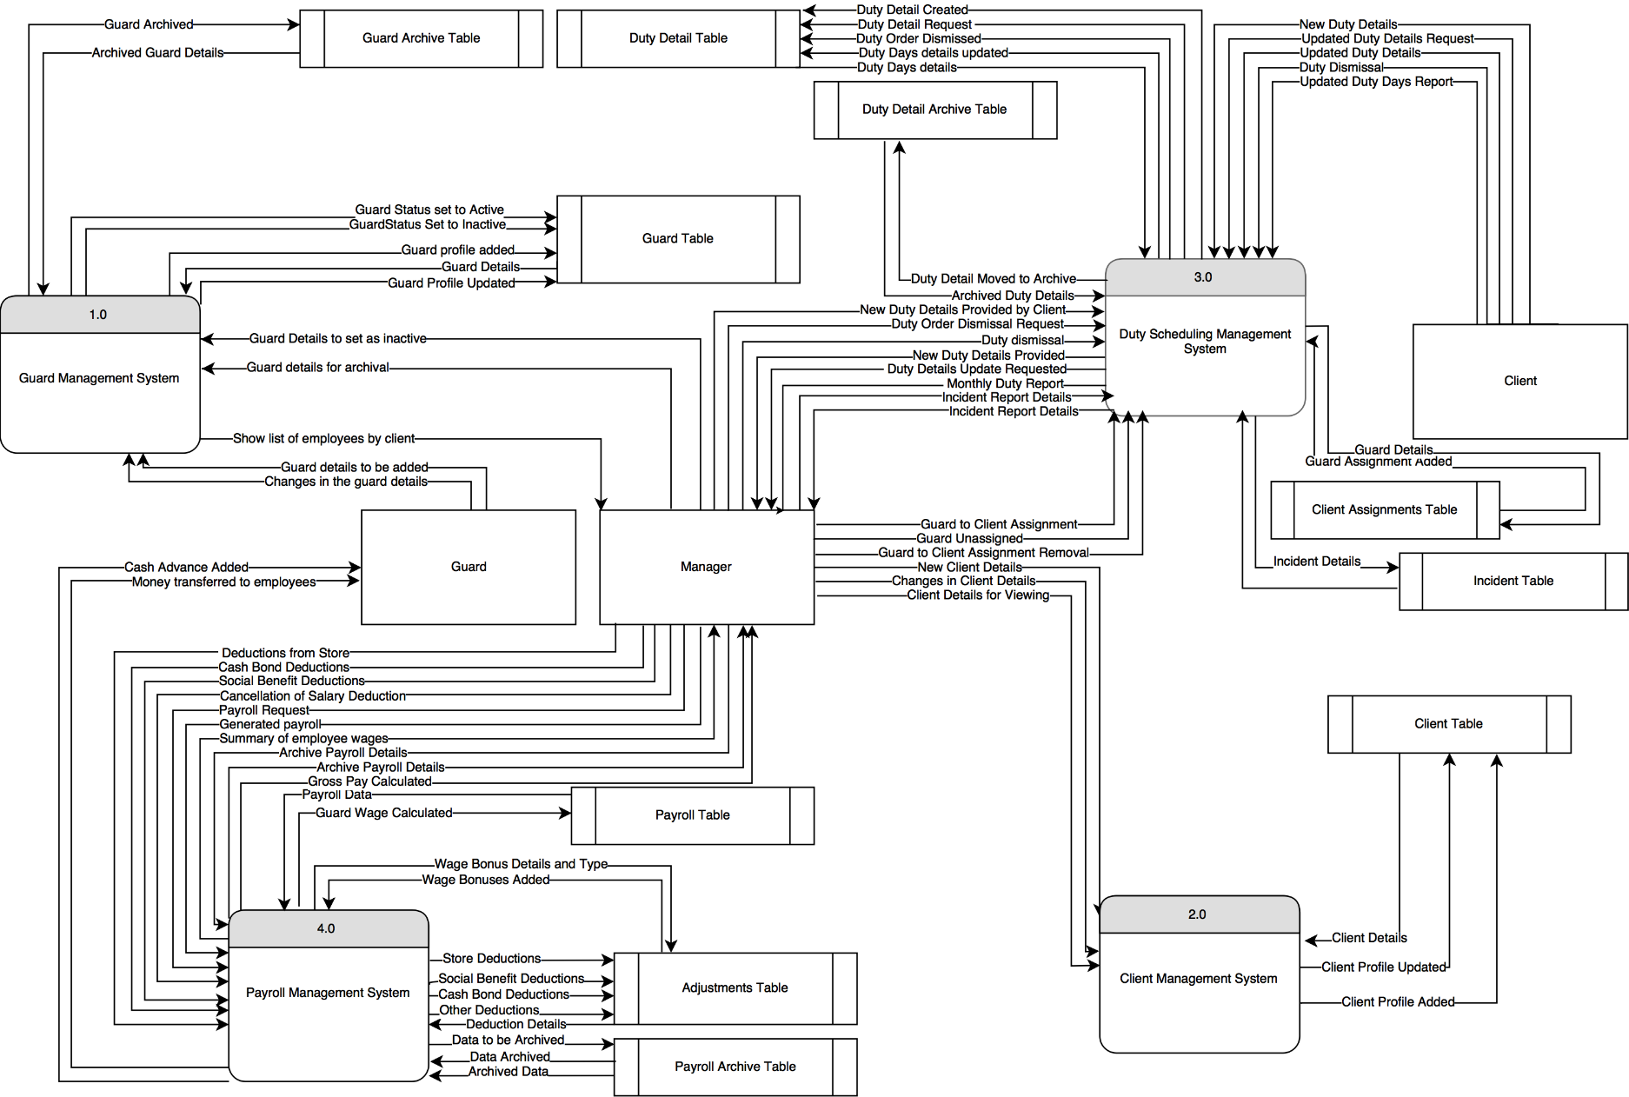**Level 1**

1. **Events List**
2. Guards Management System
   * Adds new guard
   * Edits guard Details
   * Stores old files of a guard
   * View Guards by Location
   * View Guard Archive
3. Client Management System
   * Adds new client
   * View List of Clients
   * View Client Details
   * Edits Client Details
4. Assignments and Duty Schedules Management System
   * Client requests for a guard to be assigned
   * Approves Assignment Request of a client
   * Declines Assignment Request of a client
   * Assigns a guard to a client
   * Set assigned guards to active
   * Client requests for a guard to be unassigned
   * Approves Unassignment Request of a client
   * Declines Unassignment Request of a client
   * Create Incident Report
   * Removes assigned guards
   * Considers guards with no assignment as inactive
   * Reactivates guards assigned to a client
   * Client provides duty details of guards
   * Creates Duty Details
   * Updates Duty Details
   * Dismiss Duty Details
   * Client provide duty days of guards
   * Adds Duty Days of Guards as basis for Payroll
   * Views list of guards by clients
   * Views Duty Details of Guards
   * Produces Monthly Duty Details Report
   * View Assignment History of guards
5. Payroll Management System
   * Computes gross pay of Guards
   * Adds deductions from Cash Advance
   * Adds Bonuses from 13th Month Pay
   * Adds Bonuses from Cola
   * Adds Bonuses from Emergency Allowance
   * Adds Bonuses from Cash Bonds
   * Makes adjustment for inaccurate deductions
   * Calculates Guard payroll
   * Approves Payroll calculations
   * Produce Pay slips
   * Adds holidays as basis for calculation
   * Update Holiday Information
   * Adjusts Basic Pay
   * Adjusts Rates Multiplier
   * Adjusts SSS Benefits
   * Adjusts Withholding Tax
   * Adjusts Global Rates
   * Views guard payroll
   * Views Guard adjustment history
   * Views list of guards with payroll
   * Views Payroll Rates
   * Produces Salary Reports
6. **Activity Diagram**

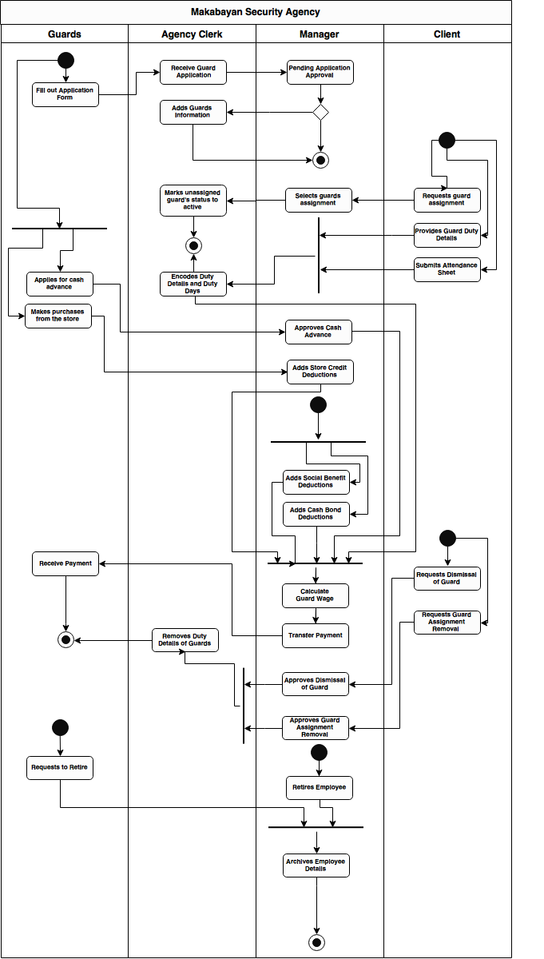

**Chapter 3**

**PROPOSED SYSTEM**

1. **Events Table**
2. Guards Management System

|  |  |  |  |  |  |
| --- | --- | --- | --- | --- | --- |
| Event | Trigger | Source | Use Case | Response | Destination |
| 1. Agency Clerk wants to add a new guard | Guard Details to be Added | Guard | Add New Guard | Guard Profile added | Guard Table |
| 2. Agency Clerk wants to edit guard details. | Changes in the guard details | Guard | Edit Guard  Details | Guard Profile updated | Guard Table |
| 3. Manager wants to store old files of a guard | Guard details to be moved to archive | Manager | Archive Guard Details | Guard details moved to archive | Guard Archive Table |
| 4. Manager wants to view guard information. | Guard Data for Viewing | Manager | View Guard Details | Show Guard Information | Manager |
| 5. Manager wants to view list of guards by location | Guard Data Location | Manager | View Guard by Location | Show Guard Information by location | Manager |
| 6. Manager wants to view guards in the archive | Guard Details in Archive | Manager | View  Guard Archive | Show list of guards in archive | Manager |
| 7. Manager wants to view summary of guards. | List of Guards | Manager | View  Guard Summary | Show Summary of Guards | Manager |

1. Client Management System

|  |  |  |  |  |  |
| --- | --- | --- | --- | --- | --- |
| Event | Trigger | Source | Use Case | Response | Destination |
| 8. Agency clerk adds a client approved by the Manager. | Client Details to be Added | Client | Add New Client | Client Profile Added | MSA Database |
| 9. Manager wants to edit client details. | Changes in Client Details | Client | Edit Client Details | Client Profile Updated | MSA Database |
| 10. Manager wants to view client details. | Client details | Manager | View Client Information | Client details is shown to the user | Manger |
| 11. Manager wants to view the list of clients. | Client Details | Manager | View list of clients | Show list of clients | Manager |

1. Assignments and Clients Management System

|  |  |  |  |  |  |
| --- | --- | --- | --- | --- | --- |
| Event | Trigger | Source | Use Case | Response | Destination |
| 12. Client requests guards to be assigned to their companies. | Client guard request | Client | Add Client Request | Client Request Added | MSA Database |
| 13. Manager declines assignment request of a client | Assignment Request  Declined | Manager | Decline Assignment Request | Client Request Declined | MSA Database |
| 14. Manager approves assignment request of a client | Assignment Request  Approval | Manager | Approve Assignment Request | Client Request Approved | MSA Database |
| 15. Manager  selects guards assigned to clients. | Guard to Client Assignment | Manager | Assign guard to Client | Guard Assignment added | MSA Database |
| 16. Client requests guards to be unassigned from their companies. | Client unassignment request | Client | Add Client Request | Client Request Added | MSA Database |
| 17. Manager declines unassignment request of a client | Unssignment Request  Declined | Manager | Decline Unssignment Request | Client Request Declined | MSA Database |
| 18. Manager approves unassignment request of a client | Unssignment Request  Approval | Manager | Approve Unssignment Request | Client Request Approved | MSA Database |
| 19. Manager wants to create an incident report. | Guard Involved in Incident | Manager | Create Incident Report | Incident Report Created | MSA Database |
| 20. Manager  removes assignment of guards to clients as approved by the manager. | Guard to Client Assignment Removal | Manager | Unassign guard from Client | Guard unassigned | MSA Database |
| 21. Manager separates guard with no assigned client and considers them as inactive. | Guard Details to set as inactive | Manager | Set Guard to inactive | Guard Status set to inactive | MSA Database |
| 22. If an inactive guard is reassigned, manager reactivates guard status. | Guard to Client Reassignment | Manager | Set Guard to active | Guard Status set to active | MSA Database |
| 23. Agency clerk encodes schedule of guards or duty details provided by the client, approved by the manager. | New Duty Details Provided by Client | Manager | Create Duty Detail | Duty Detail Created | MSA Database |
| 24. Agency clerk re-encodes schedule of guards or duty details as changed by the client, approved by the manager. | Updated Duty Details | Manager | Update Duty Details | Duty Detail Updated | MSA Database |
| 25. Agency clerk encodes number of duty days of guards provided by client as basis for payroll. | Updated Duty Days Report | Client | Update Duty Days of guard | Duty Days details updated | MSA Database |
| 26. Manager dismisses a guard from duty, as provided by the client | Duty Dismissal | Manager | Duty Detail Dismissal | Duty Dismissal | MSA Database |
| 27. Manager wants to view duty details of a guard | Guard Duty Details | Guards | View Guard Duty Details | Show summary of duty details | Manager |
| 28. Manager wants to view guards assigned to each client | Guard Duty Details | Client | View List of Guards by Clients | Show List of Guards by Clients | Manager |
| 29. Time to produce Monthly Duty Details Reports. | Every One Month |  | View Duty Details Summary | Show Monthly Duty Details Report | Manager |
| 30. Manager wants to view the history of assignments of a guard | Guard Duty Details | Manager | View Guards Assignment History | Show guard’s history of assignments | Manager |

1. Payroll Management System

|  |  |  |  |  |  |
| --- | --- | --- | --- | --- | --- |
| Event | Trigger | Source | Use Case | Response | Destination |
| 31. Manager makes bonus/deduction adjustments to payroll | New Adjustment Details | Manager | Add Payroll Adjustment | Adjustment Added | MSA Database |
| 32. Manager wants to add 13th month bonus details to a guard | 13th Month Bonus Adjustments | Manager | Adjust 13th Month Bonus Details | 13th Month Bonus Details Adjusted | MSA Database |
| 33. Manager wants to add Cola bonus details to a guard | Cola Bonus Adjustments | Manager | Adjust Cola Bonus Details | Cola Bonus Details Adjusted | MSA Database |
| 34. Manager wants to add Emergency Allowance bonus details to a guard | Emergency Allowance Bonus Adjustments | Manager | Adjust Emergency Allowance Bonus Details | Emergency Allowance Bonus Details Adjusted | MSA Database |
| 35. Manager wants to add Cash bonds bonus details to a guard | Cash bonds Bonus Adjustments | Manager | Adjust Cash bonds Bonus Details | Cash bonds  Bonus Details Adjusted | MSA Database |
| 36. Manager adds deductions from Cash advance | Cash Advance Deductions | Manager | Adjust Cash Advance Deduction Details | Cash Advance Deductions Added | MSA Database |
| 37. Manager wants to add a holiday detail as basis for payroll calculations | New Holiday Details | Manager | Add Holidays | Holiday Added | MSA Database |
| 38. Manager wants to update holiday details as basis for payroll calculations | Updated Holiday Details | Manager | Edit Holidays | Holidays Updated | MSA Database |
| 39. Manager wants to adjust the basic pay of the employees | Updated Basic Pay Details | Manager | Adjust Basic Pay | Basic Pay Adjusted | MSA Database |
| 40. Manager wants to adjust the rates multiplier of the employees | Updated rates multiplier Details | Manager | Adjust Rates Multiplier | Rates Multiplier Adjusted | MSA Database |
| 41. Manager wants to adjust the SSS Benefits categories and rates of the employees | Updated SSS Benefits Details | Manager | Adjust SSS Benefits] | SSS Benefits Adjusted | MSA Database |
| 42. Manager wants to adjust the withholding tax rates of the employees | Updated Withholding Tax rates | Manager | Adjust Withholding Tax | Withholding Tax Adjusted | MSA Database |
| 43. Manager wants to adjust the global rates such as default PHIC, HDMF, Cash Bond, Cola, and Emergency Allowance of payroll for the employees | Updated Global Rates Details | Manager | Adjust Global Rates | Global Rates Adjusted | MSA Database |
| 44. Manager wants to view the rates of the payroll | Payroll Rates | Manager | View Payroll Rates | Show Payroll rates | Manager |
| 45. Manager / Agency Clerk wants to view the list of guards with payroll | Payroll Details | Manager | View List of Guards with Payroll | Show List of Guards with Payroll | Manager |
| 46. Manager / Agency Clerk wants to view the payroll. | View Payroll Request | Manager | View Salary Report | Show generated payroll | Manager |
| 47. Manager / Agency Clerk wants to view the history of adjustments for a guard | View Adjustments request | Manager | View Guard Adjustment History | Show Adjustment History | Manager |
| 48. Manager approves the calculation of guards | Every 15th and 31st of the month. |  | Approve Guard Payroll | Guards Wage Calculated | MSA Database |
| 49. Time to distribute money to guards and produce individual pay slip, as approved by the manager | Every 15th and 31st of the month. |  | Transfer Money to Guards | Money transferred to guards | Guards |
| 50. Manager wants to view the pay slip of a guard | View Pay Slip Request | Manager | View Guard Pay Slip | Show Pay Slip preview | Manager |
| 51. Time to produce salary report. | Every Other Week |  | View List of Guard Wages | Show summary of Guard Wages | Manager |

**Use-case Models**

* 1. Use-Case Diagrams
     1. Guards Management System

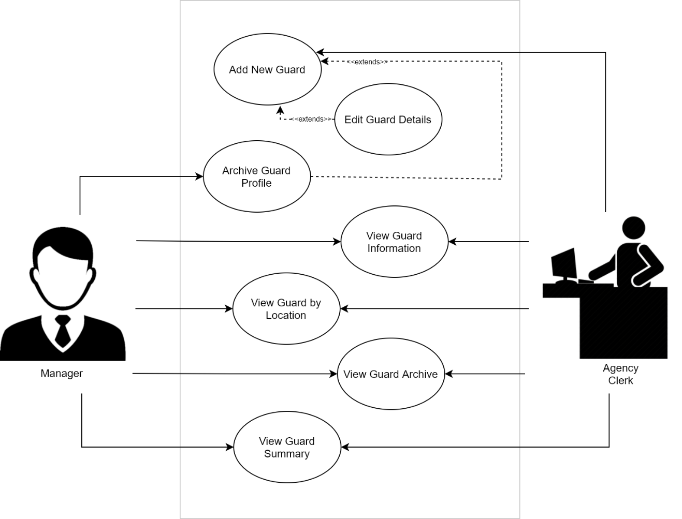

* + 1. Clients Management System

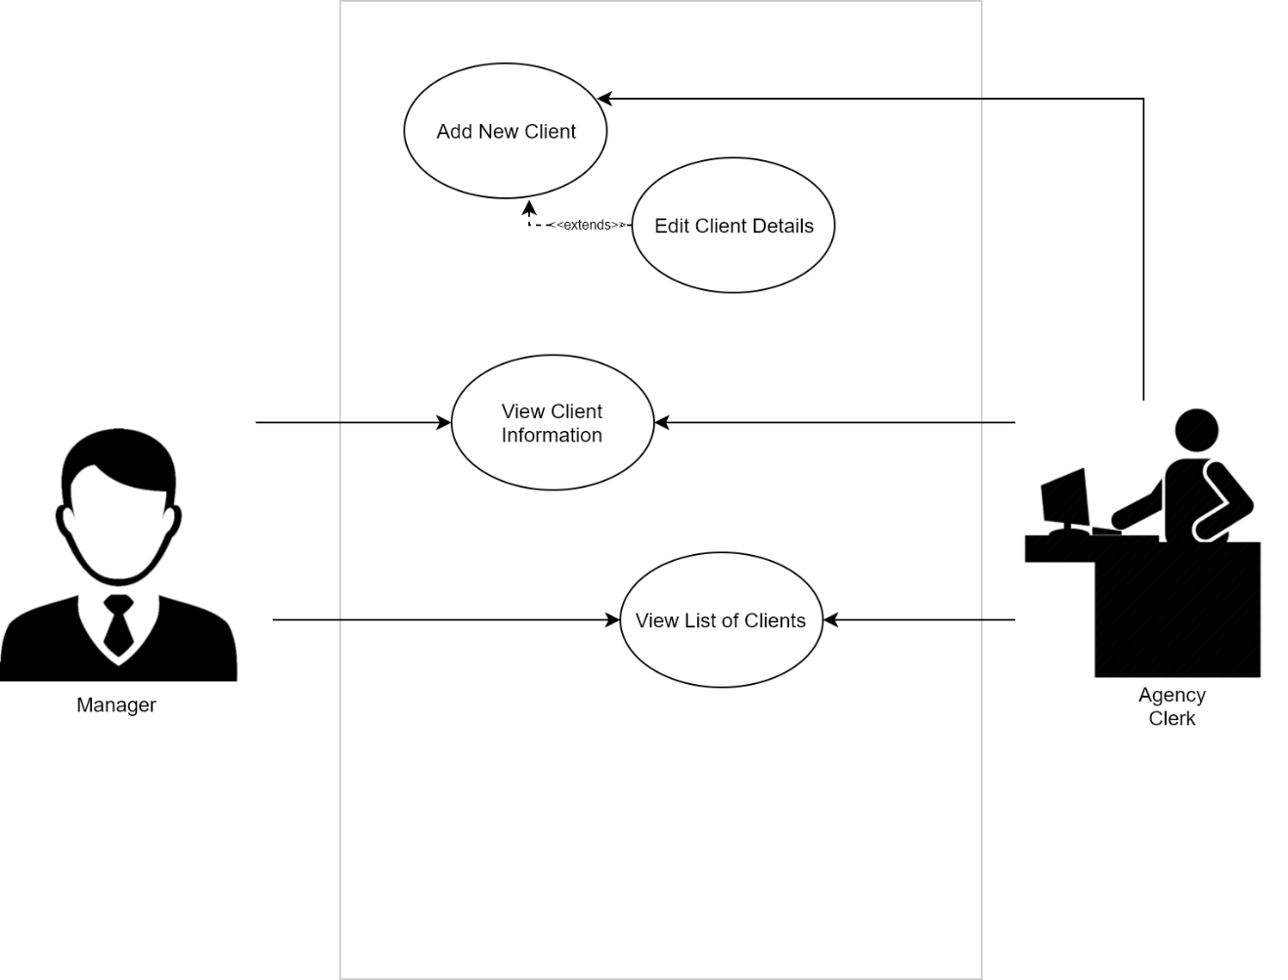

* + 1. Assignment and Duty Scheduling System

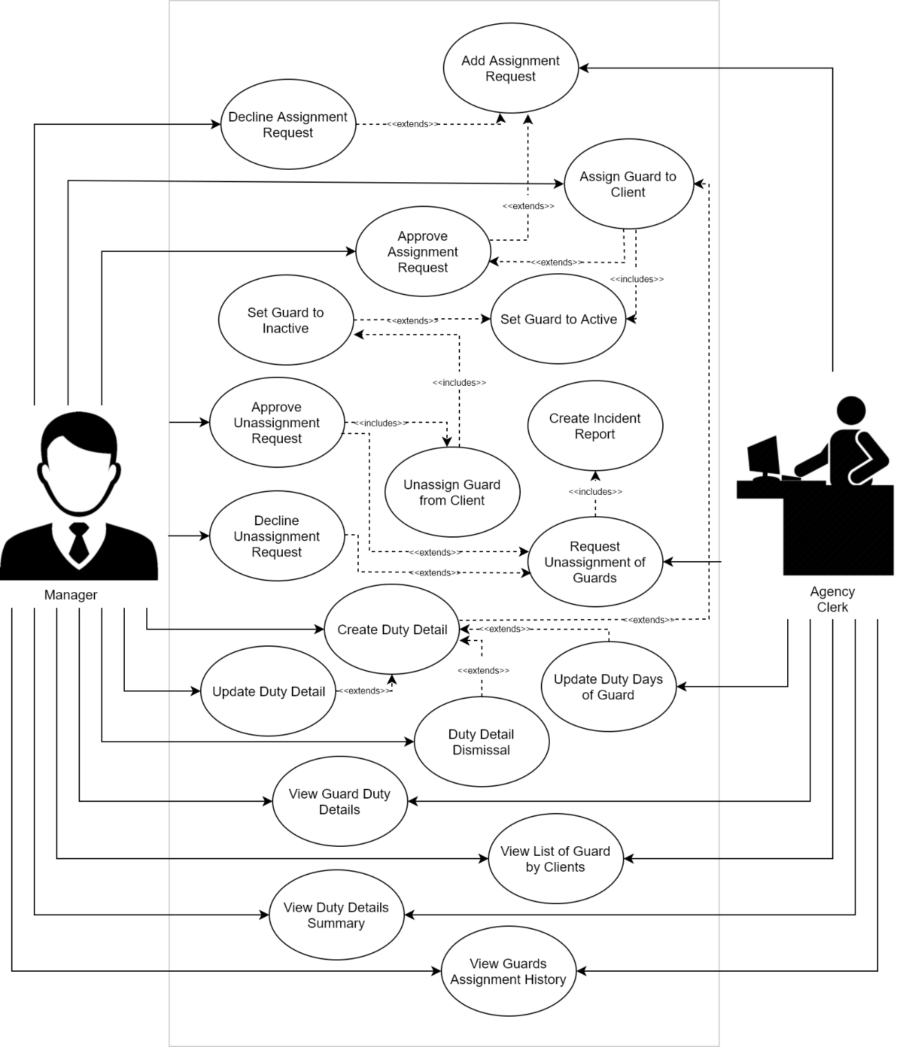

* + 1. Payroll Management

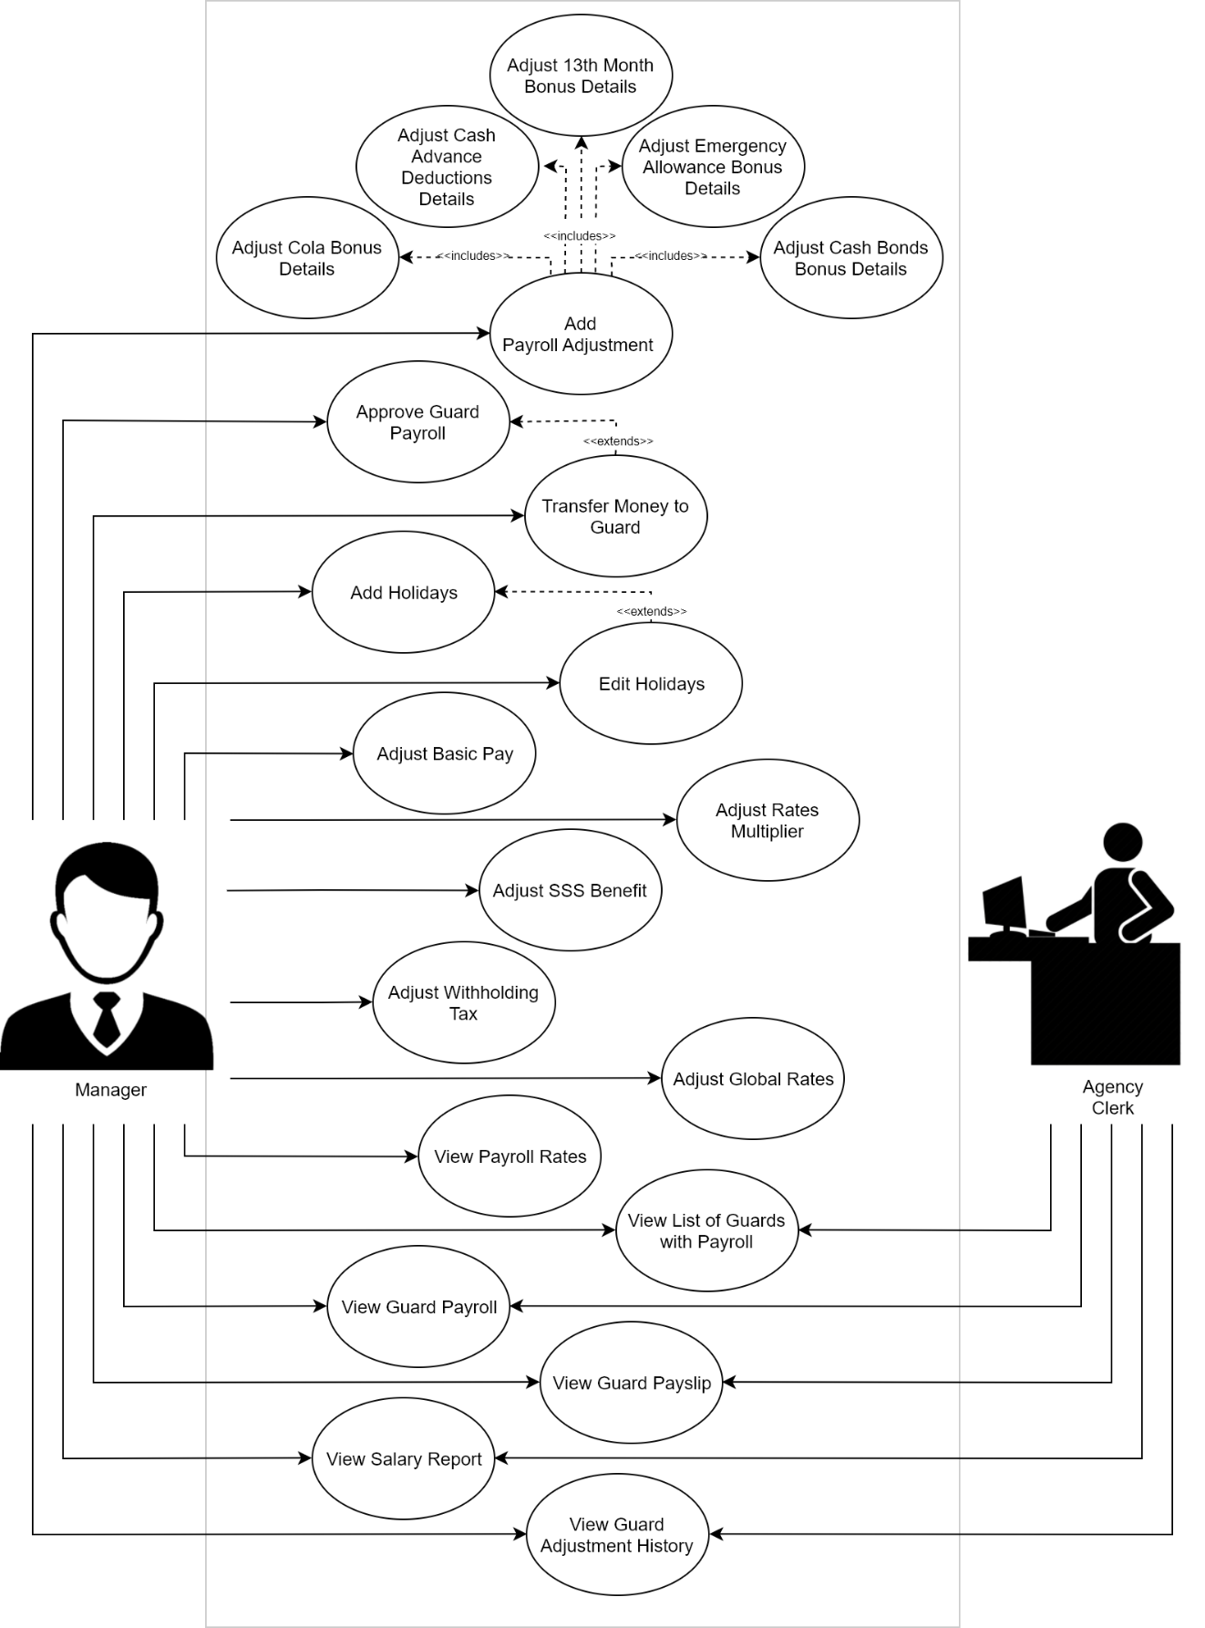

* 1. Use-case Specifications
     1. Guards Management System

|  |  |  |
| --- | --- | --- |
| **Use Case ID:** | **1** | |
| **Use Case Name:** | Add New Guard | |
| **Scenario:** | Guard’s profile will be saved to the system. | |
| **Triggering Event:** | Agency Clerk wants to add a new guard. | |
| **Actor** | Guard, Agency Clerk | |
| **Description** | After the guard fills-up the profile form, the agency clerk will encode the guard details in the system. | |
| **Related Use Cases** | <Extends> Edit Guard Details  <Extends> Add Client Request  <Extends> Archive Guard Details | |
| **Preconditions** | 1. The Profile Form must be filled out. 2. The agency clerk must receive guard details. | |
| **Post-conditions** | 1. Guard Details are added in the Guard Table | |
| **Flow of Events** | Actor:   * + - 1. The agency clerk receives the biodata sheet from the guards.       2. User clicks “Add/Edit Guard” button in the Guards and Clients Management System.       3. The user encodes the information to the “Add Guard” Window.       4. User clicks the Add button. | System:  2.1. Show “Add Guard” Window.  4.1. Save the data to the Guards table. |
| **Exception** | 1. If guard already exists, do not allow saving the same guard record. | |

|  |  |  |
| --- | --- | --- |
| **Use Case ID:** | **2** | |
| **Use Case Name:** | Edit guard details | |
| **Scenario:** | Guard profile is updated. | |
| **Triggering Event:** | Agency Clerk wants to edit guard details. | |
| **Actor** | Agency Clerk | |
| **Description** | The agency clerk updates the profile of a guard if there are new changes. | |
| **Related Use Cases** | <Extends> Add New Guard | |
| **Preconditions** | 1. The guard has changes to their details. 2. The manager wants to update the profile of the guards | |
| **Post-conditions** | 1. Guard profile is updated. | |
| **Flow of Events** | Actor:   * + - 1. The user clicks the “View Guards” button.       2. User selects a guard from the “List of Guards” page.       3. User clicks the “Edit” button.       4. User inputs the new guard data.       5. User clicks the “Save” button. | System:  1.1 Show “List of Guards” Page.  2.1 Information of selected guard is retrieved from the Guards table.  3.1. Show “Guard Details” Window, initialized with the new Guard fields.  4.1 Guard information textboxes will be enabled.  5.1 Changes are saved to the GuardTable. |
| **Exception** | 1. If there are no recent changes on the guard information, then do not save information. | |

|  |  |  |
| --- | --- | --- |
| **Use Case ID:** | **3** | |
| **Use Case Name:** | Archive Guard Details | |
| **Scenario:** | The guard detail information is archived | |
| **Triggering Event:** | Manager wants to store old files of guards. | |
| **Actor** | Manager | |
| **Description** | If the guard is no longer working, the manager can store old guard details | |
| **Related Use Cases** | <Extends> Add Guard Details | |
| **Preconditions** | 1. The guard detail information must be existing. 2. The guard must not be assigned to a client. | |
| **Post-conditions** | 1. The guard detail information is archived | |
| **Flow of Events** | Actor:   * + - 1. Manager clicks on the “View Guards” button.       2. Manager selects a guard(s) to archive.       3. Manager clicks the “Archive” button. | System:   * 1. Show List of Guards   2.1 List of guards selected are stored.  3.1 Selected Guard(s) is/are archived. |
| **Exception** | 1. If a guard is still assigned to a client, then the guard cannot be archived. | |

|  |  |  |
| --- | --- | --- |
| **Use Case ID:** | **4** | |
| **Use Case Name:** | View Guard Information | |
| **Scenario:** | Guard Status Report is generated. | |
| **Triggering Event:** | Manager wants to view guard information. | |
| **Actor** | Manager | |
| **Description** | The user can view information of a guard including their status and other information. | |
| **Related Use Cases** |  | |
| **Preconditions** | 1. Guard details must be encoded in the Guard Table | |
| **Post-conditions** | 1. Guard Status Report is generated. | |
| **Flow of Events** | Actor:   * + - 1. Manager or Manager clicks on the View Guards Button.       2. Manager selects guard from list.       3. Manager clicks on “View Button”. | System:   * 1. Show list of Guards   3.1 Show information of the selected guard.  Details |
| **Exception** | None | |

|  |  |  |
| --- | --- | --- |
| **Use Case ID:** | **5** | |
| **Use Case Name:** | View List of Guards by Location | |
| **Scenario:** | Show Guard Information by location | |
| **Triggering Event:** | Manager wants to view list of guards by location | |
| **Actor** | Manager | |
| **Description** | The user can view list of guards sorted by location in order for them to easily pinpoint who is in the area | |
| **Related Use Cases** |  | |
| **Preconditions** | 1. Guard details must be encoded in the Guard Table | |
| **Post-conditions** | 1. Show Guard Information by location | |
| **Flow of Events** | Actor:   * + - 1. User clicks on View List of Guards by Location | System:  1.1. Show list of guards by location |
| **Exception** | None | |

|  |  |  |
| --- | --- | --- |
| **Use Case ID:** | **6** | |
| **Use Case Name:** | View Guards Archive | |
| **Scenario:** | Show list of guards in archive | |
| **Triggering Event:** | Manager wants to view guards in the archive | |
| **Actor** | Manager | |
| **Description** | The manager wants to view the list of past guards recorded in the system and their details | |
| **Related Use Cases** |  | |
| **Preconditions** | * + 1. The guard details must be stored before in the system and archived in the system | |
| **Post-conditions** | * + 1. The list of guards is shown to the manager | |
| **Flow of Events** | Actor:   * + - 1. User clicks on view guard archive button | System:  1.1 View all guards in the Guard Archive table. |
| **Exception** | None | |

|  |  |  |
| --- | --- | --- |
| **Use Case ID:** | **7** | |
| **Use Case Name:** | View Guard Summary | |
| **Scenario:** | Show Summary of Guards | |
| **Triggering Event:** | Manager wants to view summary of guards. | |
| **Actor** | Manager | |
| **Description** | The manager wants to view a summary of all the guards in the system | |
| **Related Use Cases** |  | |
| **Preconditions** | 1. The guard details must be stored in the system | |
| **Post-conditions** | * 1. The summary of guards is show to the user | |
| **Flow of Events** | Actor:   * + - 1. User clicks on view guard summary button. | System:  1.1 Display summary of guards. |
| **Exception** | None | |

* 1. Client Management System

|  |  |  |
| --- | --- | --- |
| **Use Case ID:** | **8** | |
| **Use Case Name:** | Add New Client | |
| **Scenario:** | The client’s information is added to the database. | |
| **Triggering Event:** | Agency clerk adds a client approved by the Manager. | |
| **Actor** | Agency Clerk, Client | |
| **Description** | After the client fills-up the client profile from, the agency clerk will encode the details in the system. | |
| **Related Use Cases** | <Extends> Edit Client Details  <Includes> Add Client Request  <Extends> Archive Client Details | |
| **Preconditions** | 1. The client must fill-up the client profile form. 2. The agency clerk must have the client details. | |
| **Post-conditions** | 1. The client’s information is added to the database. | |
| **Flow of Events** | Actor:   * + - 1. Agency clerk clicks onthe “Add Client” button in the Guards and Clients Management System.       2. Agency clerk encodes the information.       3. Agency clicks the “Add” button to save the changes. | System:  1.1 Show the “Add Client” window.  3.1 Create new *Client* object.  3.2 Save client information to the Clients Table. |
| **Exception** | 1. If the client already exists, then do not allow saving of new information. | |

|  |  |  |
| --- | --- | --- |
| **Use Case ID:** | **9** | |
| **Use Case Name:** | Edit client details | |
| **Scenario:** | The client’s information is updated. | |
| **Triggering Event:** | Manager wants to edit client details. | |
| **Actor** | Agency Clerk | |
| **Description** | The agency clerk updates the profile of a client if there are new changes. | |
| **Related Use Cases** | Add Client Details | |
| **Preconditions** | 1. The client’s information must be existing. 2. The client has new changes to their personal information or; 3. The administrator needs to update the client’s profile. | |
| **Post-conditions** | 1. The client’s information is updated. | |
| **Flow of Events** | Actor:   * + - 1. The Agency clerk clicks on the “View Clients” button.       2. Agency clerk selects a client from list.       3. Agency clerk clicks on the “Edit” button.       4. Agency clerk encodes new client details.       5. Agency clerk clicks the “Save” | System:  1.1 Show “List of Clients” Page.  2.1 Information of selected client is retrieved from the Clients table and saved to a new *Client* object.  2.2. Show “Client Details” Window, initialized with the new *Client* object’s fields.  3.1 Client information textboxes will be enabled.  5.1 Changes are saved to the *Client* object.  5.2 Client information is saved to the *Clients Table.* |
| **Exception** | 1. If there are no new changes on the client information, do not save changes. | |

|  |  |  |
| --- | --- | --- |
| **Use Case ID:** | **10** | |
| **Use Case Name:** | View Client Details | |
| **Scenario:** | Client information is shown to the user | |
| **Triggering Event:** | Manager wants to view client information. | |
| **Actor** | Manager | |
| **Description** | The user can view information of a client including their status and other information. | |
| **Related Use Cases** |  | |
| **Preconditions** | * + - * 1. Client details must be encoded in the Guard Table | |
| **Post-conditions** | * + 1. Client information is shown to the user | |
| **Flow of Events** | Actor:   * + - 1. User clicks on the "View Clients" button.       2. User selects on a client from the list.       3. User clicks the "View Client Details" button. | System:  1.1 View List of Clients  3.1 Show client details |
| **Exception** | None | |

|  |  |  |
| --- | --- | --- |
| **Use Case ID:** | **11** | |
| **Use Case Name:** | View list of clients | |
| **Scenario:** | List of clients is shown to the user. | |
| **Triggering Event:** | Manager wants to view the list of clients. | |
| **Actor** | Manager | |
| **Description** | The user can view list of clients under the agency. | |
| **Related Use Cases** |  | |
| **Preconditions** | 1. Client details must be encoded in the Clients Table | |
| **Post-conditions** | 1. List of clients is shown to the user. | |
| **Flow of Events** | Actor:   * + - 1. The Agency Clerk / Manager clicks the “View Clients” button. | System:  1.1 Show List of Clients and their assigned guards. |
| **Exception** | None | |

* + 1. Assignments and Duty Schedules Management System

|  |  |  |
| --- | --- | --- |
| **Use Case ID:** | **12** | |
| **Use Case Name:** | Add Client Request | |
| **Scenario:** | The client’s request is sent to the manager for approval | |
| **Triggering Event:** | Client requests guards to be assigned to their companies | |
| **Actor** | Client, Agency Clerk | |
| **Description** | If the client wants to hire security guards, the client fills out the request form and the agency clerk will receive the form for approval | |
| **Related Use Cases** | <Extends> Decline Assignment Request  <Extends> Approve Assignment Request | |
| **Preconditions** | 1. The client’s information must be existing. 2. The agency clerk must have the request of the client. | |
| **Post-conditions** | 1. The client’s request is sent to the manager for approval | |
| **Flow of Events** | Actor:   * + - 1. The Agency Clerk receives the client request.       2. The agency clerk encodes the request given by the client.       3. The agency clerk clicks add to save the request. | System:  2.1 Request Form is shown to the user.  3.1 The request is added to the Requests Table. |
| **Exception** | None | |

|  |  |  |
| --- | --- | --- |
| **Use Case ID:** | **13** | |
| **Use Case Name:** | Decline Assignment Request | |
| **Scenario:** | The client’s request is decline. | |
| **Triggering Event:** | Manager declines the request of the client to assign guards | |
| **Actor** | Manager | |
| **Description** | The Agency cannot fulfill the request of the client so the manager will decline the request. | |
| **Related Use Cases** | <Extends> Add Assignment Request | |
| **Preconditions** | 1. The client’s request information must be existing. 2. The manager must have the request of the client. | |
| **Post-conditions** | 1. The client’s request is declined. | |
| **Flow of Events** | Actor:   * + - 1. The Manager views the list of requests the agency clerk encoded.       2. The Manager views the request details.       3. The manager clicks the decline button. | System:  1.1 Show list of requests  2.2 Show view Request Details Form is shown to the user.  3.1 The request status is set to declined. |
| **Exception** | 1. If the client request form is in the system, the manager cannot decline the request. | |

|  |  |  |
| --- | --- | --- |
| **Use Case ID:** | **14** | |
| **Use Case Name:** | Approve Assignment Request | |
| **Scenario:** | The client’s request is approved and will be ready for assignment. | |
| **Triggering Event:** | Manager approved the request of the client to assign guards | |
| **Actor** | Manager | |
| **Description** | The agency can fulfill the request of the client and they can provide the number of guards needed for it so the manager will approve the request | |
| **Related Use Cases** | <Extends> Add Assignment Request  <Extends> Assign Guard to Client | |
| **Preconditions** | 1. The client’s request information must be existing. 2. The manager must have the request of the client. | |
| **Post-conditions** | 1. The client’s request is approved and will be ready for assigning. | |
| **Flow of Events** | Actor:   * + - 1. The Manager views the list of requests the agency clerk encoded.       2. The Manager views the request details.       3. The manager clicks the approve button. | System:  1.1 Show list of requests  2.1 Show view Request Details are shown to the user.  3.1 The request status is set to approved. |
| **Exception** | * + - * 1. If the client request form is not encoded by the agency clerk or is not in the system, then the manager should not approve it.         2. If the number of guards requested is more than the number of guards available, then the manager should not approve it, | |

|  |  |  |
| --- | --- | --- |
| **Use Case ID:** | **15** | |
| **Use Case Name:** | Assign Guard to client | |
| **Scenario:** | The guard is assigned to the client. | |
| **Triggering Event:** | Manager selects guards assigned to clients. | |
| **Actor** | Manager | |
| **Description** | Once the manager approves the request of the client, the manager will assign the guard to the client. | |
| **Related Use Cases** | <Extends> Approve Assignment Request  <Extends> Create Duty Details  <Includes> Set Guards to Active | |
| **Preconditions** | 1. The client may or may not have sent a request to assign the guard to them. | |
| **Post-conditions** | 1. The guard is assigned to the client 2. The guard status is set to active | |
| **Flow of Events** | Actor:   * + - 1. The Manager views the list of requests the agency clerk encoded.       2. The Manager views the details of an approved request.       3. The manager clicks the “Assign” button.       4. The Manager selects the guards to be assigned from the “Available Guards” table.       5. The manager clicks “Add” button to save the choices.       6. The manager clicks “Assign” button to finish the assignment. | System:   * 1. Show list of requests   2.1 Show view request details form   * 1. Show assignment form   2. Show list of guards available   4.1 List of guards selected are stored  5.1 The selected guards are moved to the assigned table  6.1 Assignments are stored in the SDuty_Assignment Table. |
| **Exception** | 1. If the guard does not exist, then do not assign the guard.  2. If the guard is already assigned to the same client, then the guard cannot be assigned anymore.  3. If the guard is already assigned to an assignment which overlaps the requested contract time frame, then the guards cannot be assigned to the client. | |

|  |  |  |  |
| --- | --- | --- | --- |
| **Use Case ID:** | | **16** | |
| **Use Case Name:** | | Request Unassignment of Guards | |
| **Scenario:** | | The client’s unassignment request is sent to the manager for approval | |
| **Triggering Event:** | | Client requests guards to be unassigned to their companies | |
| **Actor** | | Client, Agency Clerk | |
| **Description** | | If the client wants to remove security guards, the client fills out the request form and the agency clerk will receive the form for approval | |
| **Related Use Cases** | | <Includes> Create Incident Report  <Extends> Decline Unassignment Request  <Extends> Approve Unassignment Request | |
| **Preconditions** | | 1. The client’s information must be existing. 2. The agency clerk must have the request of the client. | |
| **Post-conditions** | | 1. The client’s request is sent to the manager for approval | |
| **Flow of Events** | Actor:   * + - 1. The Agency Clerk receives the client request.       2. The agency clerk checks the list of guards assigned to the client.       3. The Agency clerk clicks the “Unassign” button.       4. The agency clerk encodes the request detail from the client.       5. The agency clerk clicks “Request” button to add the request. | | System:  2.1 Show list of guards assigned to the client  3.1 The guards selected are stored  4.1 Show add unassignment request form.  5.1 The unassignment request is stored in the Request Table |
| **Exception** | 1. If the client request form is not from the client, then the agency clerk should not encode the request to the system.  2. If the guard has still an active duty detail for the assignment, then the guard cannot be assigned.  3. If the agency clerk did not add an incident report for the request, the agency clerk cannot add the request. | | |

|  |  |  |
| --- | --- | --- |
| **Use Case ID:** | **17** | |
| **Use Case Name:** | Decline Unassignment Request | |
| **Scenario:** | The client’s request is decline. | |
| **Triggering Event:** | Manager declines the request of the client to unassign guards | |
| **Actor** | Manager | |
| **Description** | If the manager did not find sufficient evidence about the unassignment of the guards or the agency clerk misadded the request, then the manager declines the request. | |
| **Related Use Cases** | <Extends> Request Unassignment of guards | |
| **Preconditions** | 1. The client’s request information must be existing. 2. The manager must have the request of the client. | |
| **Post-conditions** | 1. The client’s request is declined. | |
| **Flow of Events** | Actor:   * + - 1. The Manager views the list of requests the agency clerk encoded.       2. The Manager views the request details.       3. The manager clicks the decline button. | System:  1.1 Show list of requests  2.1 Show view Request Details are shown to the user.  3.1 The request status is set to declined. |
| **Exception** | 1. If the client request form is in the system, the manager cannot decline the request. | |

|  |  |  |
| --- | --- | --- |
| **Use Case ID:** | **18** | |
| **Use Case Name:** | Approve Unassignment Request | |
| **Scenario:** | The client’s request is approved and the guards will be unassigned to the requesting client. | |
| **Triggering Event:** | Manager approved the request of the client to unassign guards | |
| **Actor** | Manager | |
| **Description** | If the manager finds sufficient proof to unassign guards, the manager can approve the request to unassign the requested guards. | |
| **Related Use Cases** | <Extends> Request Unassignment of Guards  <Includes> Unassign Guard from Client | |
| **Preconditions** | 1. The client’s request information must be existing. 2. The manager must have the request of the client. | |
| **Post-conditions** | 1. The client’s request is approved and will be ready for assigning. | |
| **Flow of Events** | Actor:   * + - 1. The Manager views the list of requests the agency clerk encoded.       2. The Manager views the request details.       3. The manager clicks the approve button. | System:  1.1 Show list of requests  2.1 Show view Request Details are shown to the user.  3.1 The request status is set to approved. |
| **Exception** | * + - * 1. If the client request form is not encoded by the agency clerk or is not in the system, then the manager should not approve it. | |

|  |  |  |
| --- | --- | --- |
| **Use Case ID:** | **19** | |
| **Use Case Name:** | Create Incident Report | |
| **Scenario:** | An incident report is created | |
| **Triggering Event:** | An incident occurred involving a guard causing him to be unassigned. | |
| **Actor** | Manager | |
| **Description** | If an incident involving a specific guard occurs, an incident report is created by the manager. | |
| **Related Use Cases** | <Includes> Request Unassignment of Guards | |
| **Preconditions** | 1. An incident involving a guard must have occurred. | |
| **Post-conditions** | 1. An incident report is created | |
| **Flow of Events** | Actor:   * + - 1. The agency clerk clicks the “Add Incident Report” while the agency clerk is at the request unassignment form.       2. The agency clerk encodes the incident details | System:  1.1 Show add incident report form |
| **Exception** | None | |

|  |  |  |
| --- | --- | --- |
| **Use Case ID:** | **20** | |
| **Use Case Name:** | Unassign Guard from Client | |
| **Scenario:** | The guard is removed from the assigned guards to the client. | |
| **Triggering Event:** | Manager removes assignment of guards to clients as approved by the manager. | |
| **Actor** | Manager | |
| **Description** | If the guard is removed or the manager wants to remove the assignment of a guard to the client, the manager unassign the guard | |
| **Related Use Cases** | <Includes> Approve Unassignment Request  <Includes> Set Guard to Inactive | |
| **Preconditions** | 1. The guard must be assigned to the client. 2. A request to unassign must be added by agency clerk or the manager. | |
| **Post-conditions** | 1. The guard is removed from the assigned guards to the client. 2. If the guard has no more assignment, the guard is set to inactive. | |
| **Flow of Events** | Actor:   * + - 1. After the manager approves the request of the client, the unassignment will be done in the system. | System:   * 1. The request is set to active   2. The guards are unassigned from the client |
| **Exception** | * + - * 1. If the guard is not assigned to the guard, then the guard cannot be unassigned.         2. If there are no request made to unassign the guards, the guard cannot be unassigned. | |

|  |  |  |
| --- | --- | --- |
| **Use Case ID:** | **21** | |
| **Use Case Name:** | Set Guard to Inactive | |
| **Scenario:** | The guard status will be set to inactive | |
| **Triggering Event:** | Manager separates guard with no assigned client and considers them as inactive. | |
| **Actor** | Manager | |
| **Description** | If the guard has no assignment, the guard is set to inactive. | |
| **Related Use Cases** | <Extends> Set Guard to Active  <Includes> Unassign Guard to Client | |
| **Preconditions** | 1. The guard must not be assigned to any client, 2. The guard status must be active; or 3. The guard is new and not assigned to any client. | |
| **Post-conditions** | 1. The guard status will be set to inactive | |
| **Flow of Events** | Actor:   * + - 1. Manager unassigns guard from client. | System:   * 1. The system checks if the guard has other assignments.   2. The guard’s status is set to inactive |
| **Exception** | 1. If a guard is already inactive, then the guard cannot be set to inactive. | |

|  |  |  |
| --- | --- | --- |
| **Use Case ID:** | **22** | |
| **Use Case Name:** | Set Guard to Active | |
| **Scenario:** | The guard status is set to active | |
| **Triggering Event:** | If an inactive guard is reassigned, manager reactivates guard status. | |
| **Actor** | Manager | |
| **Description** | The guard will be set to active if the guard is reassigned to a client | |
| **Related Use Cases** | <Includes> Assign Guard to Client  <Extends> Set guard to inactive. | |
| **Preconditions** | 1. The guard status must be inactive 2. The guard must be assigned to a client | |
| **Post-conditions** | 1. The guard status is set to active | |
| **Flow of Events** | Actor:   * + - 1. Manager assigns guard to a client. | System:  1.1 The guard status is set to active |
| **Exception** | 1. If a guard is already active, then do not activate again a guard.  2. If a guard is not assigned to any client, then do not allow the guard to be active. | |

|  |  |  |
| --- | --- | --- |
| **Use Case ID:** | **23** | |
| **Use Case Name:** | Create Duty Details | |
| **Scenario:** | Guard’s New Duty Details are stored in the system. | |
| **Triggering Event:** | Agency clerk encodes schedule of guards or duty details provided by the client, approved by the manager. | |
| **Actor** | Agency Clerk, Manager | |
| **Description** | Once the manager approves the duty details provided by the client, the agency clerk will create duty detail. | |
| **Related Use Cases** | <Extends> Update Duty Detail  <Extends> Duty Detail Dismissal  <Extends> Update Duty Days of Guards  <Extends> Assign Guard to Client | |
| **Preconditions** | 1. The manager must approve new duty details. 2. The agency clerk must have the duty details information. 3. The Guard to be created with a duty must be existing. 4. The Guard must be assigned to a client | |
| **Post-conditions** | 1. Guard’s New Duty Details are stored in the system. | |
| **Flow of Events** | Actor:   * + - 1. Agency Clerk / Manager Views the list of guards assigned to a client.       2. Agency Clerk / Manager selects the guard to be scheduled.       3. Agency clerk / Manager click on the “Add Duty Details” button.       4. Agency clerk / manager encodes schedule of guards or duty details provided by the client, approved by the manager.       5. Agency clerk / Manager clicks the save button. | System: |
| **Exception** | 1. If the guard does not exist, then do not allow the creation of duty details.  2. If the guard is not assigned to the client, then do not create duty details.  3. If the given schedule is more than or less than 8 hours, then do not add the schedule. | |

|  |  |  |
| --- | --- | --- |
| **Use Case ID:** | **24** | |
| **Use Case Name:** | Update Duty Detail | |
| **Scenario:** | Guard’s Duty Details are updated. | |
| **Triggering Event:** | Agency clerk re-encodes schedule of guards or duty details as changed by the client, approved by the manager. | |
| **Actor** | Manager | |
| **Description** | Once the manager approves the new changes to the duty details, the agency clerk updates the duty details of a guard. | |
| **Related Use Cases** | <Extends> Create Duty Detail | |
| **Preconditions** | 1. The Duty Details must be existing. 2. The Duty Details update must be approved by the manager. | |
| **Post-conditions** | 1. Guard’s Duty Details are updated. | |
| **Flow of Events** | Actor:   * + - 1. Agency clerk / Manager click on the “Edit Duty Details” button.       2. Agency clerk re-encodes schedule of guards or duty details as changed by the client, approved by the manager. | System: |
| **Exception** | If there are no new changes are committed, then do not save the changes. | |

|  |  |  |
| --- | --- | --- |
| **Use Case ID:** | **25** | |
| **Use Case Name:** | Update Duty Days of guard | |
| **Scenario:** | Duty days of the guard must be stored in the system. | |
| **Triggering Event:** | Agency clerk encodes number of duty days of guards provided by client as basis for payroll. | |
| **Actor** | Client, Agency Clerk | |
| **Description** | Once the client sends the duty days of a guard, the agency clerk encodes and updates the duty days of a guard as basis for payroll. | |
| **Related Use Cases** | <Extends> Create Duty Detail | |
| **Preconditions** | 1. The client must give the duty days of a guard. 2. The agency clerk must have the duty days information of the guard. 3. The guard must be existing. 4. The guard must be assigned to the client. 5. The guard must have duty details. | |
| **Post-conditions** | 1. Duty days of the guard must be stored in the system. | |
| **Flow of Events** | Actor:   * + - 1. Agency Clerk / Manager Views the list of guards assigned to a client.       2. Agency Clerk / Manager selects the guard to be scheduled.       3. Agency clerk / Manager click on the “Attendance” button.       4. Agency clerk / manager selects the current payroll period.       5. Agency clerk / manager clicks the “Edit duty days” button.       6. Agency clerk / manager encodes the attendance of the guard.       7. Agency clerk / manager clicks “Save” button to add the attendance as basis for payroll. | System:   * 1. Show list of guards assigned to the client   2.1 Initialize view guard assignment details  3.1 Initialize view attendance form  4.1 Show list of payroll periods  5.1 Edit Duty days from is shown  7.1 Attendance is added to the system. |
| **Exception** | 1. If the guard does not exist, then do not allow the updating of duty days.  2. If the guard duty details do not exist, then do not allow updating of duty days.  3. if the guard is not assigned to the client, then do not allow the updating of duty days. | |

|  |  |  |
| --- | --- | --- |
| **Use Case ID:** | **26** | |
| **Use Case Name:** | Duty Order Dismissal | |
| **Scenario:** | The guard is dismissed from its duty details. | |
| **Triggering Event:** | Manager approves guard dismissal from duty | |
| **Actor** | Manager | |
| **Description** | Once the manager approves the Duty Order Dismissal, the guard is dismissed from the duty. | |
| **Related Use Cases** | <Extends> Create Duty Detail | |
| **Preconditions** | 1. The client may have requested the dismissal of a guard to the client. 2. The guard details must be existing. 3. The guard duty details must be existing. 4. The guard must be assigned to the client. | |
| **Post-conditions** | 1. The guard is dismissed from its duty details. | |
| **Flow of Events** | Actor:   * + - 1. Agency Clerk / Manager clicks the “Dismiss” button while in the view assignment page. | System:  1.1 The duty detail is removed from the system |
| **Exception** | 1. If the guard does not exist, then do not allow the dismissal of duty order.  2. If the guard duty details do not exist, then do not allow the dismissal of duty order.  3. if the guard is not assigned to the client, then do not allow the dismissal of duty order. | |

|  |  |  |
| --- | --- | --- |
| **Use Case ID:** | **27** | |
| **Use Case Name:** | View Guard Duty Details | |
| **Scenario:** | The user can see the Duty Details of a guard | |
| **Triggering Event:** | Manager wants to view duty details of a guard | |
| **Actor** | Agency Clerk, Manager | |
| **Description** | The user can view the duty details of a guard sorted by clients. | |
| **Related Use Cases** |  | |
| **Preconditions** | 1. The Guard Duty Details must be existing. | |
| **Post-conditions** | 1. The user can see the Duty Details of a guard | |
| **Flow of Events** | Actor:   * + - 1. Manager clicks on the “View Assignments” button. | System:  1.1 Show View Guard Duty Details Form |
| **Exception** | None | |

|  |  |  |
| --- | --- | --- |
| **Use Case ID:** | **28** | |
| **Use Case Name:** | View List of Guards by Client | |
| **Scenario:** | List of Guards by assigned client is generated. | |
| **Triggering Event:** | Manager wants to view list of guards by client | |
| **Actor** | Agency Clerk, Manager | |
| **Description** | User can view the list of guards sorted by the client it is assigned to | |
| **Related Use Cases** |  | |
| **Preconditions** | 1. Guard Details must be in the Guard Table. 2. Client Details must be in the Client Table. 3. Guards must be assigned to a client. | |
| **Post-conditions** | 1. List of Guards by assigned client is generated. | |
| **Flow of Events** | Actor:   * + - 1. Agency Clerk or Manager clicks on the View Guards Button. | System:  1.1 Show list of guards assigned by client |
| **Exception** | None | |

|  |  |  |
| --- | --- | --- |
| **Use Case ID:** | **29** | |
| **Use Case Name:** | View Duty Details Summary | |
| **Scenario:** | Monthly Duty Details Summary will be produced | |
| **Triggering Event:** | Time to produce Monthly Duty Details Reports. | |
| **Actor** |  | |
| **Description** | After every one month, the system will produce a Monthly Duty Details Summary for the agency | |
| **Related Use Cases** |  | |
| **Preconditions** | 1. Duty Details must be stored in the system. | |
| **Post-conditions** | 1. Monthly Duty Report will be produced | |
| **Flow of Events** | Actor:   * + - * 1. Every one month, Monthly Duty Report will be created. | System:  1.1 Produce Duty Details Summary |
| **Exception** | None | |

|  |  |  |
| --- | --- | --- |
| **Use Case ID:** | **30** | |
| **Use Case Name:** | View Guards Assignment History | |
| **Scenario:** | Show guard’s history of assignments | |
| **Triggering Event:** | Manager wants to view the history of assignments of a guard | |
| **Actor** | Manager | |
| **Description** | The manager wants to view the list of past duty details of guards recorded in the system and its details | |
| **Related Use Cases** |  | |
| **Preconditions** | The duty details of guards must be stored before in the system | |
| **Post-conditions** | The duty details of guards are shown to the manager | |
| **Flow of Events** | Actor:   * + - * 1. Agency clerk / manager clicks “Guard History” button.         2. Agency clerk / manager selects guards with past assignments from the list.         3. Agency clerk / manager clicks the “View Details” button to view the details of the past assignment. | System:  1.1 Guards with past assignments are shown to the user  3.1 Show view assignment details to the user |
| **Exception** | If the guard does not have any past assignment, then do not show guard on the list. | |

* 1. Payroll Management System

|  |  |  |
| --- | --- | --- |
| **Use Case ID:** | **31** | |
| **Use Case Name:** | Add Payroll Adjustment | |
| **Scenario:** | Manager wants to add an adjustment to the payroll of the guard | |
| **Triggering Event:** | Manager makes bonus/deduction adjustments to payroll | |
| **Actor** | Manager | |
| **Description** | If the manager made an inaccurate or wants to add a bonus/deduction, the manager can adjust the payroll in the system. | |
| **Related Use Cases** | <Includes> Adjust Cola Bonus Details  <Includes> Adjust 13th Month Bonus Details  <Includes> Adjust Emergency Allowance Bonus Details  <Includes> Adjust Cash Bonds Bonus Details  <Includes> Adjust Cash Advance Deductions Details | |
| **Preconditions** | 1. The guard details must be existing. 2. The payroll details must be existing. | |
| **Post-conditions** | 1. The bonus/deduction details are added. | |
| **Flow of Events** | Actor:   * + - * 1. Manager selects guards with payroll form list.         2. Manager clicks “View Details Button”         3. Manager clicks “Adjust” Button.         4. Manager encodes the bonus/deductions details.         5. Manager clicks “Save” button. | System:  1.1 Show list of guards with payroll  2.1 Show View Payroll details form  3.1 Show adjustments form  5.1 The adjustment is save in the system |
| **Exception** | 1. If the payroll does not exist, then do allow addition of bonus/deduction. | |

|  |  |  |
| --- | --- | --- |
| **Use Case ID:** | **32** | |
| **Use Case Name:** | Adjust 13th Month Bonus Details | |
| **Scenario:** | Manager wants to add an 13th Month Bonus Details adjustment to the payroll of the guard | |
| **Triggering Event:** | Manager wants to add/adjust 13th month bonus details to a guard | |
| **Actor** | Manager | |
| **Description** | If the manager made an inaccurate or wants to add a bonus detail, the manager can adjust it in the system. | |
| **Related Use Cases** | <Includes> Add Payroll Adjustment | |
| **Preconditions** | 1. The guard details must be existing. 2. The payroll details must be existing. 3. If the manager wants to adjust, the 13th month bonus detail must be existing. | |
| **Post-conditions** | 1. The 13th month bonus details are adjusted. | |
| **Flow of Events** | Actor:   * + - * 1. Manager selects guards with payroll form list.         2. Manager clicks “View Details Button”         3. Manager clicks “Adjust” Button.         4. Manager encodes the bonus detail.         5. Manager clicks “Save” button. | System:  1.1 Show list of guards with payroll  2.1 Show View Payroll details form  3.1 Show adjustments form  5.1 The adjustment is save in the system |
| **Exception** | If the payroll does not exist, then do allow addition of bonus.  If the manager wants to adjust and the 13th month bonus detail does not exist, then do not allow addition of bonus. | |

|  |  |  |
| --- | --- | --- |
| **Use Case ID:** | **33** | |
| **Use Case Name:** | Adjust Cola Bonus Details | |
| **Scenario:** | Manager wants to add an Cola Bonus Details adjustment to the payroll of the guard | |
| **Triggering Event:** | Manager wants to add/adjust Cola bonus details to a guard | |
| **Actor** | Manager | |
| **Description** | If the manager made an inaccurate or wants to add a bonus detail, the manager can adjust it in the system. | |
| **Related Use Cases** | <Includes> Add Payroll Adjustment | |
| **Preconditions** | 1. The guard details must be existing. 2. The payroll details must be existing. 3. If the manager wants to adjust, the Cola bonus detail must be existing. | |
| **Post-conditions** | 1. The Cola bonus details are adjusted. | |
| **Flow of Events** | Actor:   * + - * 1. Manager selects guards with payroll form list.         2. Manager clicks “View Details Button”         3. Manager clicks “Adjust” Button.         4. Manager encodes the bonus detail.         5. Manager clicks “Save” button. | System:  1.1 Show list of guards with payroll  2.1 Show View Payroll details form  3.1 Show adjustments form  5.1 The adjustment is save in the system |
| **Exception** | If the payroll does not exist, then do allow addition of bonus.  If the manager wants to adjust and the Cola bonus detail does not exist, then do not allow addition of bonus. | |

|  |  |  |
| --- | --- | --- |
| **Use Case ID:** | **34** | |
| **Use Case Name:** | Adjust Emergency Allowance Bonus Details | |
| **Scenario:** | Manager wants to add an Emergency Allowance Bonus Details adjustment to the payroll of the guard | |
| **Triggering Event:** | Manager wants to add/adjust Emergency Allowance bonus details to a guard | |
| **Actor** | Manager | |
| **Description** | If the manager made an inaccurate or wants to add a bonus detail, the manager can adjust it in the system. | |
| **Related Use Cases** | <Includes> Add Payroll Adjustment | |
| **Preconditions** | 1. The guard details must be existing. 2. The payroll details must be existing. 3. If the manager wants to adjust, the Emergency Allowance bonus detail must be existing. | |
| **Post-conditions** | 1. The Emergency Allowance bonus details are adjusted. | |
| **Flow of Events** | Actor:   * + - * 1. Manager selects guards with payroll form list.         2. Manager clicks “View Details Button”         3. Manager clicks “Adjust” Button.         4. Manager encodes the bonus detail.         5. Manager clicks “Save” button. | System:  1.1 Show list of guards with payroll  2.1 Show View Payroll details form  3.1 Show adjustments form  5.1 The adjustment is save in the system |
| **Exception** | If the payroll does not exist, then do allow addition of bonus.  If the manager wants to adjust and the Emergency Allowance bonus detail does not exist, then do not allow addition of bonus. | |

|  |  |  |
| --- | --- | --- |
| **Use Case ID:** | **35** | |
| **Use Case Name:** | Adjust Cash Bonds Bonus Details | |
| **Scenario:** | Manager wants to add an Cash Bonds Bonus Details adjustment to the payroll of the guard | |
| **Triggering Event:** | Manager wants to add/adjust Cash Bonds bonus details to a guard | |
| **Actor** | Manager | |
| **Description** | If the manager made an inaccurate or wants to add a bonus detail, the manager can adjust it in the system. | |
| **Related Use Cases** | <Includes> Add Payroll Adjustment | |
| **Preconditions** | 1. The guard details must be existing. 2. The payroll details must be existing. 3. If the manager wants to adjust, the Cash Bonds bonus detail must be existing. | |
| **Post-conditions** | 1. The Cash Bonds bonus details are adjusted. | |
| **Flow of Events** | Actor:   * + - * 1. Manager selects guards with payroll form list.         2. Manager clicks “View Details Button”         3. Manager clicks “Adjust” Button.         4. Manager encodes the bonus detail.         5. Manager clicks “Save” button. | System:  1.1 Show list of guards with payroll  2.1 Show View Payroll details form  3.1 Show adjustments form  5.1 The adjustment is save in the system |
| **Exception** | If the payroll does not exist, then do allow addition of bonus.  If the manager wants to adjust and the Cash Bonds bonus detail does not exist, then do not allow addition of bonus. | |

|  |  |  |
| --- | --- | --- |
| **Use Case ID:** | **36** | |
| **Use Case Name:** | Adjust Cash Advance Deduction Details | |
| **Scenario:** | Manager wants to add an Cash Advance Deduction Details adjustment to the payroll of the guard | |
| **Triggering Event:** | Manager wants to add/adjust Cash Advance Deduction details to a guard | |
| **Actor** | Manager | |
| **Description** | If the manager made an inaccurate or wants to add a Deduction detail, the manager can adjust it in the system. | |
| **Related Use Cases** | <Includes> Add Payroll Adjustment | |
| **Preconditions** | 1. The guard details must be existing. 2. The payroll details must be existing. 3. If the manager wants to adjust, the Cash Advance Deduction detail must be existing. | |
| **Post-conditions** | 1. The Cash Advance Deduction details are adjusted. | |
| **Flow of Events** | Actor:   * + - * 1. Manager selects guards with payroll form list.         2. Manager clicks “View Details Button”         3. Manager clicks “Adjust” Button.         4. Manager encodes the Deduction detail.         5. Manager clicks “Save” button. | System:  1.1 Show list of guards with payroll  2.1 Show View Payroll details form  3.1 Show adjustments form  5.1 The adjustment is save in the system |
| **Exception** | If the payroll does not exist, then do allow addition of Deduction.  If the manager wants to adjust and the Cash Advance Deduction detail does not exist, then do not allow addition of Deduction. | |

|  |  |  |
| --- | --- | --- |
| **Use Case ID:** | **37** | |
| **Use Case Name:** | Add Holidays | |
| **Scenario:** | The manager wants to add a holiday as basis for payroll calculations. | |
| **Triggering Event:** | Manager wants to add a holiday detail as basis for payroll calculations. | |
| **Actor** | Manager | |
| **Description** | The manager can add new holidays as basis for payroll calculations. | |
| **Related Use Cases** | <Extends> Edit Holidays | |
| **Preconditions** | 1. The new holiday details must be existing | |
| **Post-conditions** | 1. The holiday details are added. | |
| **Flow of Events** | Actor:   * + - * 1. Manager clicks “Configure Holidays” button.         2. Manager selects a date from the calendar.         3. Manager encodes additional details for the holiday.         4. Manager clicks “Save” to add the holiday details | System:  1.1 Show Configure Holiday Form  1.2 Show list of holidays  2.1 Show add mode for calendar  4.1 The holiday is saved in the system |
| **Exception** | None | |

|  |  |  |
| --- | --- | --- |
| **Use Case ID:** | **38** | |
| **Use Case Name:** | Edit Holidays | |
| **Scenario:** | The manager wants to update a holiday as basis for payroll calculations. | |
| **Triggering Event:** | Manager wants to update a holiday detail as basis for payroll calculations. | |
| **Actor** | Manager | |
| **Description** | The manager can update new holiday details as basis for payroll calculations. | |
| **Related Use Cases** | <Extends> Edit Holidays | |
| **Preconditions** | 1. The new holiday details must be existing | |
| **Post-conditions** | 1. The holiday details are updated. | |
| **Flow of Events** | Actor:   * + - * 1. Manager clicks “Configure Holidays” button.         2. Manager selects a date to be configure in the list.         3. Manger clicks “Remove” to remove the old details of the holiday.         4. Manager selects a new date from the calendar.         5. Manager encodes additional details for the holiday.         6. Manager clicks “Save” to add the holiday details | System:  1.1 Show Configure Holiday Form  1.2 Show list of holidays  2.1 Show add mode for calendar  3.1 Remove the old info from the system  4.1 Show add mode for the new holiday  6.1 The current holiday information is saved in the system |
| **Exception** | None | |

|  |  |  |
| --- | --- | --- |
| **Use Case ID:** | **39** | |
| **Use Case Name:** | Adjust Basic Pay | |
| **Scenario:** | Manager has current information about the basic pay as basis for the payroll. | |
| **Triggering Event:** | Manager wants to adjust the basic pay of the employees | |
| **Actor** | Manager | |
| **Description** | If the manager has current information of employee’s basic pay, then the manager can adjust it. | |
| **Related Use Cases** |  | |
| **Preconditions** | 1. The old basic pay details must be existing. | |
| **Post-conditions** | 1. The current basic pay details are added. | |
| **Flow of Events** | Actor:   * + - * 1. Manager clicks “Configure Rates” button.         2. Manager clicks “Basic Pay” button.         3. Manager clicks the edit button.         4. Manager encodes the current basic pay information.         5. Manager clicks “Save” button. | System:  1.1 Show configure rates button  2.1 Show the Edit Basic Pay page  3.1 Show Basic Pay Edit Mode  5.1 Save the current Basic Pay Info. |
| **Exception** | None | |

|  |  |  |
| --- | --- | --- |
| **Use Case ID:** | **40** | |
| **Use Case Name:** | Adjust Rates Multipliers | |
| **Scenario:** | Manager has current information about the Rates Multipliers as basis for the payroll. | |
| **Triggering Event:** | Manager wants to adjust the Rates Multipliers of the employees | |
| **Actor** | Manager | |
| **Description** | If the manager has current information of employee’s Rates Multipliers, then the manager can adjust it. | |
| **Related Use Cases** |  | |
| **Preconditions** | 1. The old Rates Multipliers details must be existing. | |
| **Post-conditions** | 1. The current Rates Multipliers details are added. | |
| **Flow of Events** | Actor:   * + - * 1. Manager clicks “Configure Rates” button.         2. Manager clicks “Rates Multipliers” button.         3. Manager clicks the edit button.         4. Manager encodes the current Rates Multipliers information.         5. Manager clicks “Save” button. | System:  1.1 Show configure rates button  2.1 Show the Edit Rates Multipliers page  3.1 Show Rates Multipliers Edit Mode  5.1 Save the current Rates Multipliers Info. |
| **Exception** | If the encoded details are not valid, as checked by manager, then do not save the current details. | |

|  |  |  |
| --- | --- | --- |
| **Use Case ID:** | **41** | |
| **Use Case Name:** | Adjust SSS Benefit | |
| **Scenario:** | Manager has current information about the SSS Benefit as basis for the payroll. | |
| **Triggering Event:** | Manager wants to adjust the SSS Benefit of the employees | |
| **Actor** | Manager | |
| **Description** | If the manager has current information of employee’s SSS Benefit, then the manager can adjust it. | |
| **Related Use Cases** |  | |
| **Preconditions** | 1. The old SSS Benefit details must be existing. | |
| **Post-conditions** | 1. The current SSS Benefit details are added. | |
| **Flow of Events** | Actor:   * + - * 1. Manager clicks “Configure Rates” button.         2. Manager clicks “SSS Benefit” button.         3. Manager clicks the edit button.         4. Manager encodes the current SSS Benefit information.         5. Manager clicks “Save” button. | System:  1.1 Show configure rates button  2.1 Show the Edit SSS Benefit page  3.1 Show SSS Benefit Edit Mode  5.1 Save the current SSS Benefit Info. |
| **Exception** | If the encoded details are not valid, as checked by manager, then do not save the current details. | |

|  |  |  |
| --- | --- | --- |
| **Use Case ID:** | **42** | |
| **Use Case Name:** | Adjust Withholding Tax | |
| **Scenario:** | Manager has current information about the Withholding Tax as basis for the payroll. | |
| **Triggering Event:** | Manager wants to adjust the Withholding Tax of the employees | |
| **Actor** | Manager | |
| **Description** | If the manager has current information of employee’s Withholding Tax, then the manager can adjust it. | |
| **Related Use Cases** |  | |
| **Preconditions** | 1. The old Withholding Tax details must be existing. | |
| **Post-conditions** | 1. The current Withholding Tax details are added. | |
| **Flow of Events** | Actor:   * + - * 1. Manager clicks “Configure Rates” button.         2. Manager clicks “Withholding Tax” button.         3. Manager clicks the edit button.         4. Manager encodes the current Withholding Tax information.         5. Manager clicks “Save” button. | System:  1.1 Show configure rates button  2.1 Show the Edit Withholding Tax page  3.1 Show Withholding Tax Edit Mode  5.1 Save the current Withholding Tax Info. |
| **Exception** | If the encoded details are not valid, as checked by manager, then do not save the current details. | |

|  |  |  |
| --- | --- | --- |
| **Use Case ID:** | **43** | |
| **Use Case Name:** | Adjust Global Rates | |
| **Scenario:** | Manager has current information about the Global Rates as basis for the payroll. | |
| **Triggering Event:** | Manager wants to adjust the Global Rates of the employees | |
| **Actor** | Manager | |
| **Description** | If the manager has current information of employee’s Global Rates, then the manager can adjust it. | |
| **Related Use Cases** |  | |
| **Preconditions** | 1. The old Global Rates details must be existing. | |
| **Post-conditions** | 1. The current Global Rates details are added. | |
| **Flow of Events** | Actor:   * + - * 1. Manager clicks “Configure Rates” button.         2. Manager clicks “Global Rates” button.         3. Manager clicks the edit button.         4. Manager encodes the current Global Rates information.         5. Manager clicks “Save” button. | System:  1.1 Show configure rates button  2.1 Show the Edit Global Rates page  3.1 Show Global Rates Edit Mode  5.1 Save the current Global Rates Info. |
| **Exception** | If the encoded details are not valid, as checked by manager, then do not save the current details. | |

|  |  |  |
| --- | --- | --- |
| **Use Case ID:** | **44** | |
| **Use Case Name:** | View Payroll Rates | |
| **Scenario:** | Manager wants to view or check the rates as basis for the payroll | |
| **Triggering Event:** | Manager wants to view the rates of the payroll | |
| **Actor** | Manager | |
| **Description** | The manager can view the payroll rates | |
| **Related Use Cases** |  | |
| **Preconditions** | 1. The payrolls rates must be stored in the system. | |
| **Post-conditions** | 1. Payroll rates are shown to the manager. | |
| **Flow of Events** | Actor:   * + - * 1. Manager clicks “Configure Rates” button. | System:  1.1 Show Configure Rates to user |
| **Exception** | None | |

|  |  |  |
| --- | --- | --- |
| **Use Case ID:** | **45** | |
| **Use Case Name:** | View List of Guards with Payroll | |
| **Scenario:** | Manager or the agency clerk wants to view or check the guards with an existing payroll. | |
| **Triggering Event:** | Manager or the agency clerk wants to view the list of guards with payroll | |
| **Actor** | Manager, Agency Clerk | |
| **Description** | The user can view the payroll rates | |
| **Related Use Cases** |  | |
| **Preconditions** | 1. The payrolls details must be stored in the system. | |
| **Post-conditions** | 1. Payroll details are shown to the manager. | |
| **Flow of Events** | Actor:   * + - * 1. Manager / Agency Clerk click “View Employees” button under the Payroll Module. | System:  1.1 Show list of guards with payroll |
| **Exception** | None | |

|  |  |  |
| --- | --- | --- |
| **Use Case ID:** | **46** | |
| **Use Case Name:** | View Salary Report | |
| **Scenario:** | Payroll Summary is generated. | |
| **Triggering Event:** | Manager wants to view the payroll. | |
| **Actor** | Manager, Agency Clerk | |
| **Description** | The user can view the summary of the payrolls | |
| **Related Use Cases** |  | |
| **Preconditions** | 1. The payrolls must be stored in the system. | |
| **Post-conditions** | 1. Payroll Summary is generated. | |
| **Flow of Events** | Actor:   * + - * 1. The Agency Clerk is tasked by the manager to give payroll summary of guards.         2. The Agency Clerk clicks the View Salary Report button. | System:  2.1 Show Salary Report page to user. |
| **Exception** | None | |

|  |  |  |
| --- | --- | --- |
| **Use Case ID:** | **47** | |
| **Use Case Name:** | View Guard Adjustment History | |
| **Scenario:** | Guard Adjustment History is shown to the user. | |
| **Triggering Event:** | Manager or agency clerk wants to view the history of adjustments for a guard | |
| **Actor** | Manager, Agency Clerk | |
| **Description** | The user can view the adjustment made to the payroll of the guard | |
| **Related Use Cases** |  | |
| **Preconditions** | 1. The payroll adjustments must be stored in the system. | |
| **Post-conditions** | 1. Payroll adjustment history is shown to the user. | |
| **Flow of Events** | Actor:   * + - * 1. The User selects a guard with a payroll from the list.         2. The user views the details of the guard.         3. The user selects a payroll period.         4. The user clicks “Adjustments” button. | System:  1.1 Show list of guards with payroll  2.1 Show view payroll details form  3.1 Show list of payroll period  4.1 Show list of adjustments to user |
| **Exception** | None | |

|  |  |  |
| --- | --- | --- |
| **Use Case ID:** | **48** | |
| **Use Case Name:** | Approve Guard Payroll | |
| **Scenario:** | The manager checked the calculations of the payroll and is now ready to be transferred to the guard. | |
| **Triggering Event:** | Manager approves the calculation of guards | |
| **Actor** | Manager | |
| **Description** | The manager, after checking, can now approve the payroll of the guard for it to finalize its computation. | |
| **Related Use Cases** | <Extends> Transfer Money to Guard | |
| **Preconditions** | 1. The payroll details must be stored in the system. 2. The manager must have checked the calculations | |
| **Post-conditions** | 1. The payroll is finalized and approved | |
| **Flow of Events** | Actor:   * + - * 1. The User selects a guard with a payroll from the list.         2. The user views the details of the guard.         3. The user clicks the “Approve” button. | System:  1.1 Show list of guards with payroll  2.1 Show view payroll details for the guard  3.1 The payroll status is set to approved. |
| **Exception** | If the calculation has some errors, the manager should not approve the payroll and make some adjustments. | |

|  |  |  |
| --- | --- | --- |
| **Use Case ID:** | **49** | |
| **Use Case Name:** | Transfer Money to Guards | |
| **Scenario:** | The money will be transferred to the guards | |
| **Triggering Event:** | Time to distribute money to guards and print individual pay slip. | |
| **Actor** |  | |
| **Description** | If it is the 15th or 31st of the month, the manager will transfer the money to the guards. | |
| **Related Use Cases** | <Extends> Approve Guard Payroll | |
| **Preconditions** | 1. The wage must be calculated. | |
| **Post-conditions** | 1. The money will be transferred to the guards | |
| **Flow of Events** | Actor:   * + - * 1. When it is time to distribute money to guards, money is transferred to the guards. | System:  1.1 Transfer Money to Guards |
| **Exception** | 1. If the guard wage is not yet calculated/approved, then do not allow the transfer of money. | |

|  |  |  |
| --- | --- | --- |
| **Use Case ID:** | **50** | |
| **Use Case Name:** | View Guard Pay Slip | |
| **Scenario:** | Guard Pay Slip preview is generated and shown to the manager | |
| **Triggering Event:** | Manager wants to view the pay slip of the guard. | |
| **Actor** |  | |
| **Description** | A pay slip preview will be shown to the manager and from then he can export it to a file. | |
| **Related Use Cases** |  | |
| **Preconditions** | 1. The guard wages must be calculated and stored in the system. | |
| **Post-conditions** | 1. The Pay Slip is generated | |
| **Flow of Events** | Actor:   * + - * 1. Manager or Manager clicks on the View Payroll Button.         2. Manager clicks “Payslip” button. | System:  1.1 Show view payroll details of guard  2.1 Show pay slip preview to user |
| **Exception** | None | |

|  |  |  |
| --- | --- | --- |
| **Use Case ID:** | **51** | |
| **Use Case Name:** | View List of Guard Wages | |
| **Scenario:** | The Salary Report is generated | |
| **Triggering Event:** | Time to produce salary report. | |
| **Actor** |  | |
| **Description** | Every one week, the system will produce a salary report. | |
| **Related Use Cases** |  | |
| **Preconditions** | 1. The guard wages must be calculated. | |
| **Post-conditions** | 1. The Salary Report is generated | |
| **Flow of Events** | Actor:   * + - * 1. Manager or Manager clicks on the View Payroll Summary Button. | System:  1.1 Show List of Guard Wages |
| **Exception** | None | |

1. **Sequence Diagrams**
   1. Guards Management System

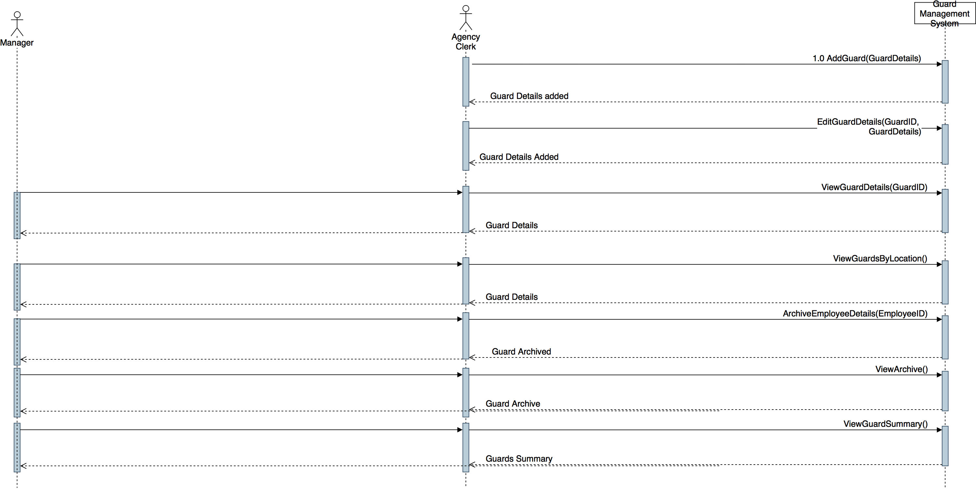

* 1. Clients Management System

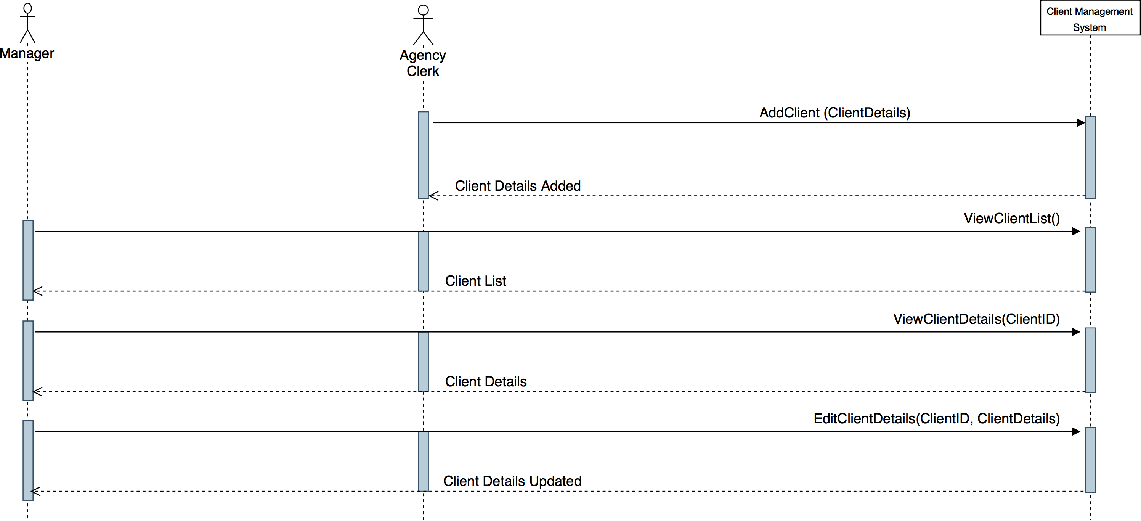

* 1. Assignments and Duty Schedules Management System

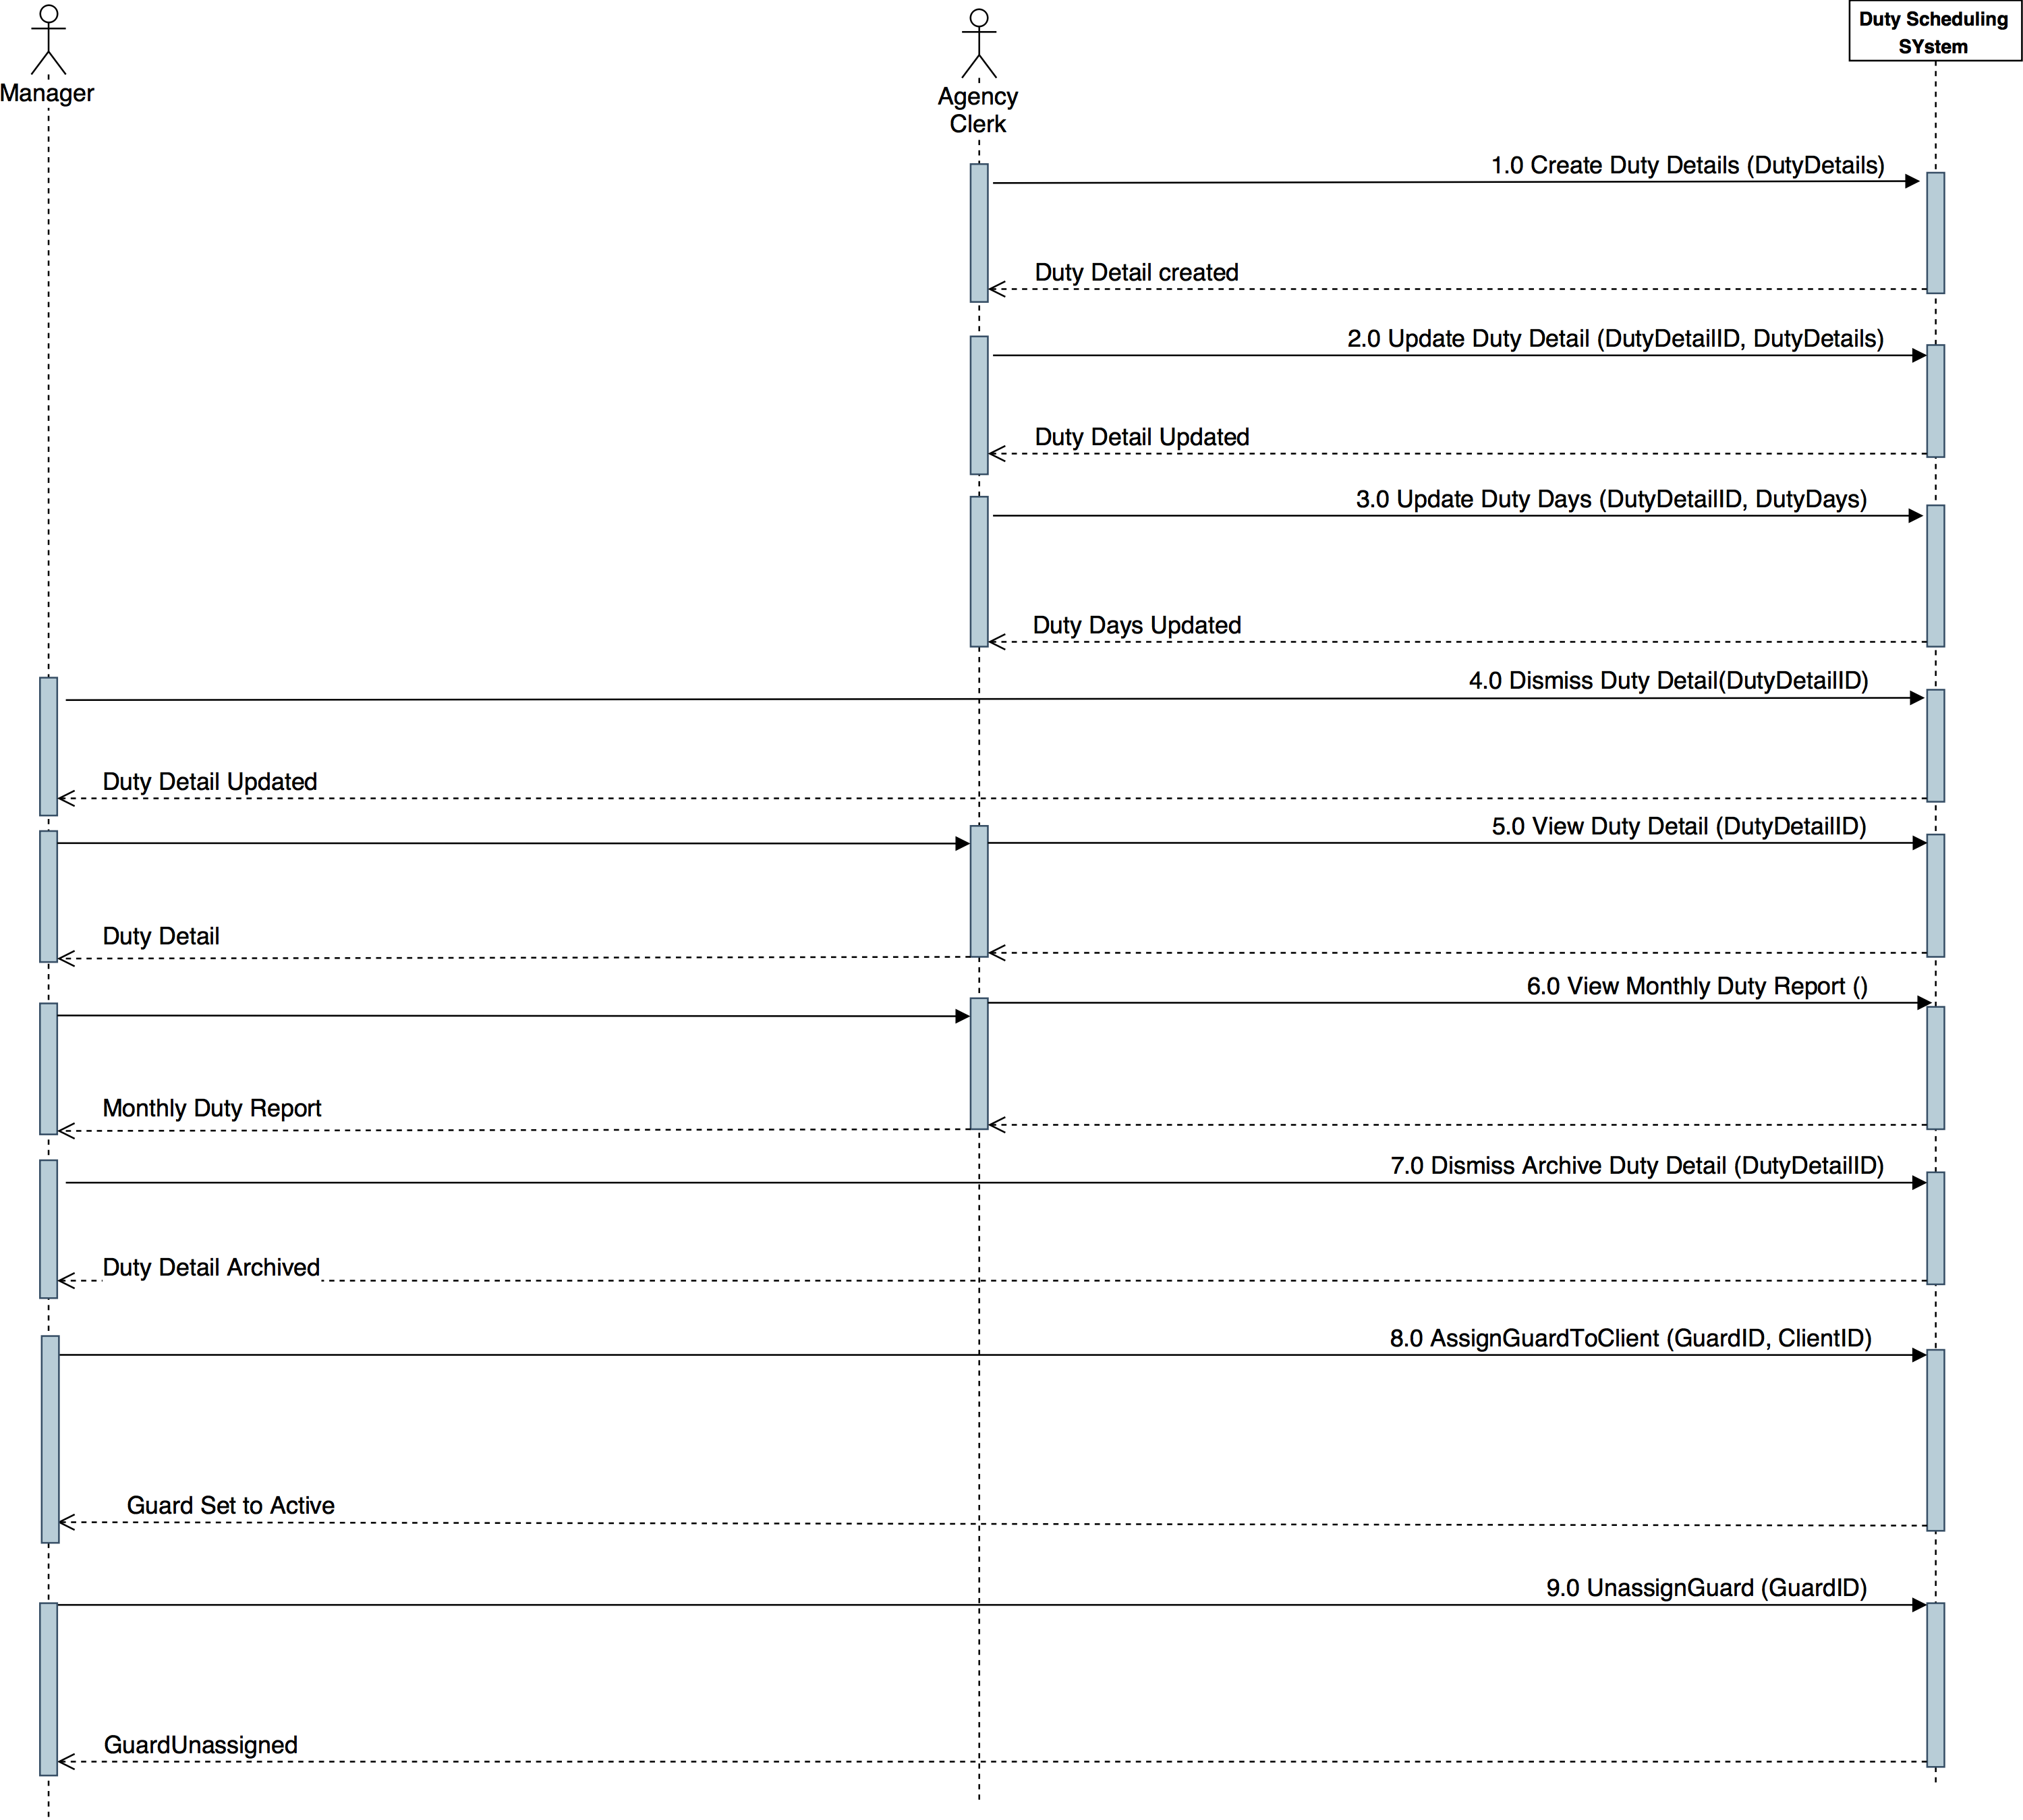

* 1. Payroll Management System

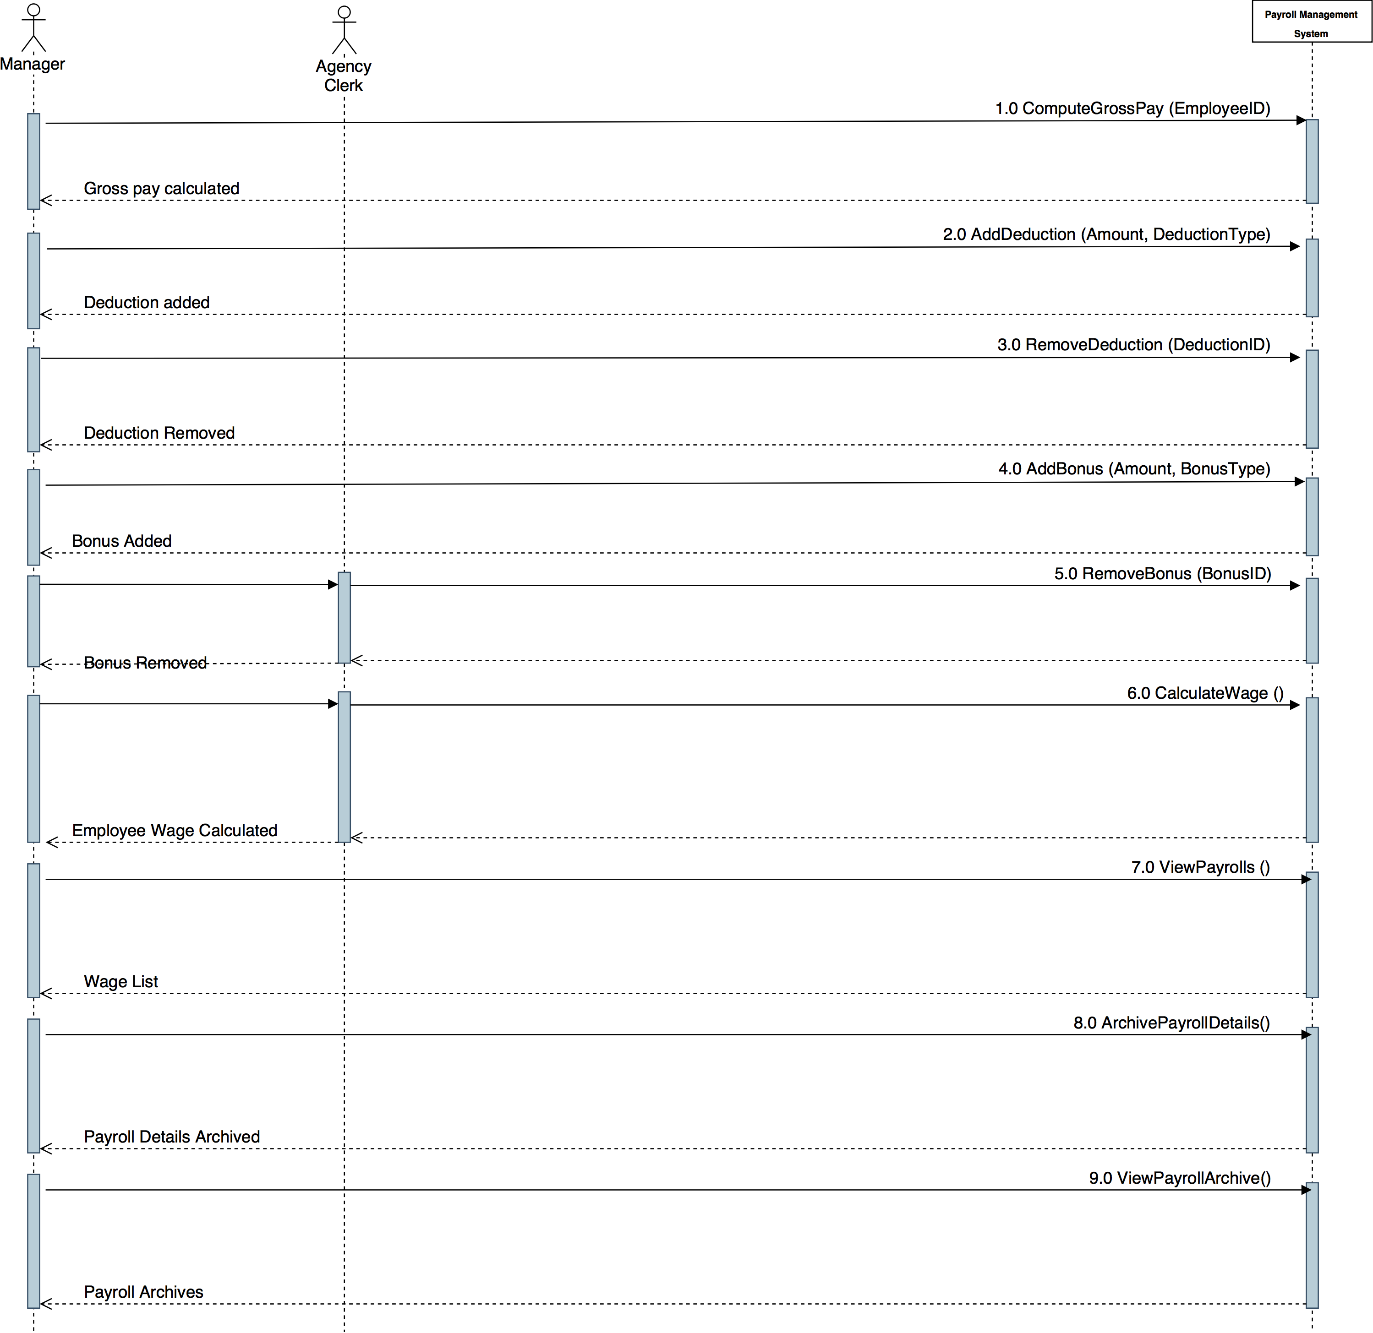

1. **Domain Class Diagram**
   1. **MSA Database**

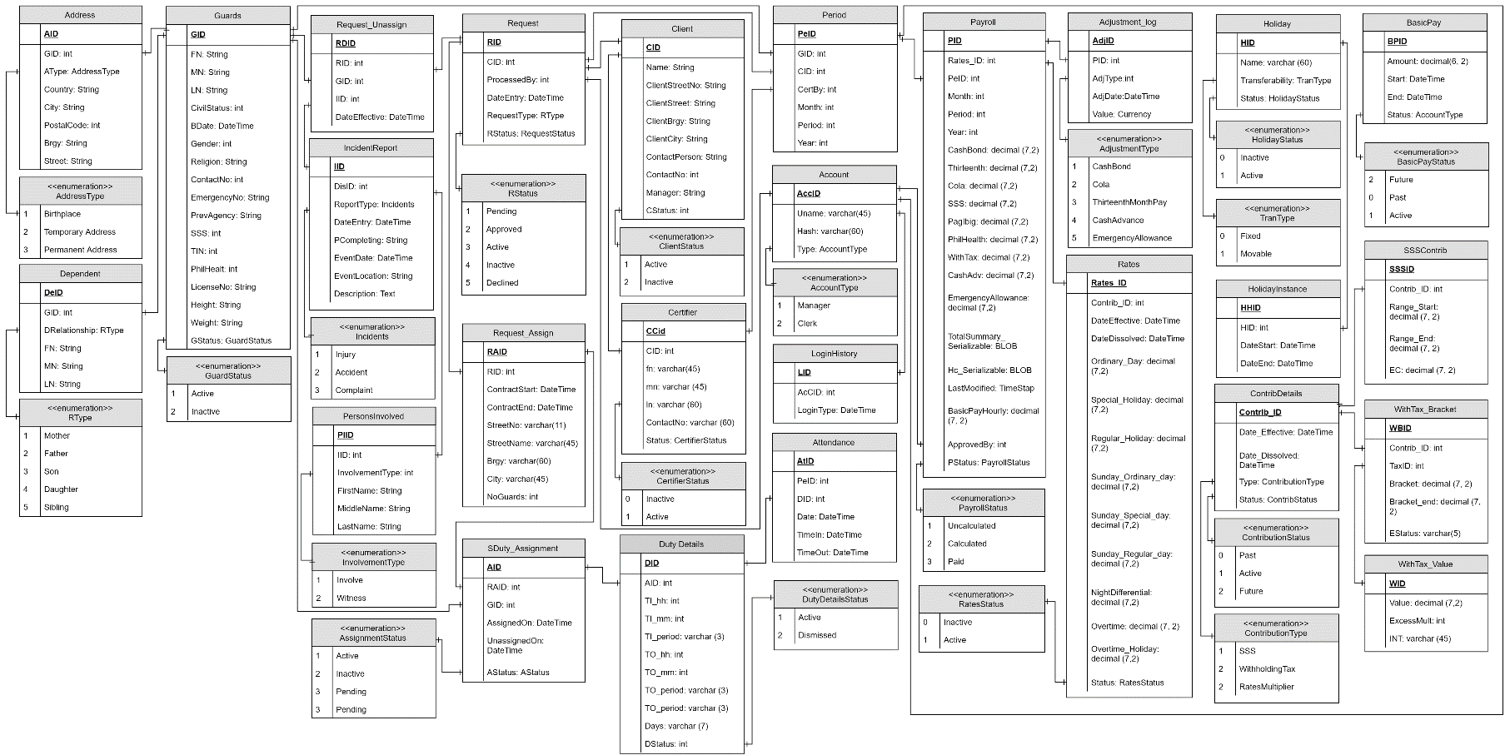

* 1. **Archive Database**

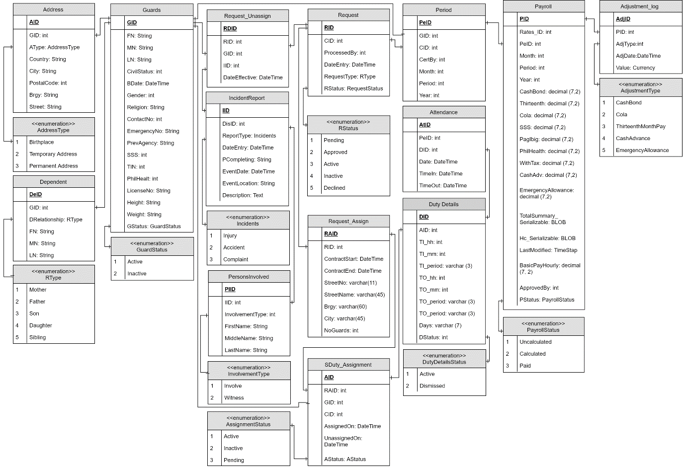

1. 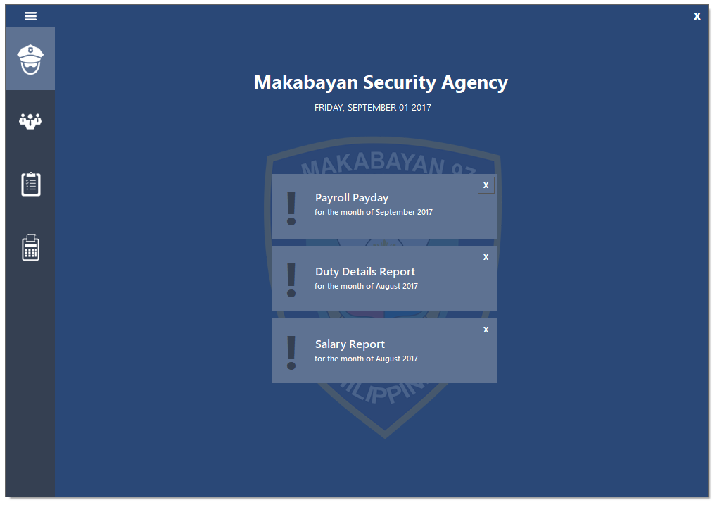**Screenshots**

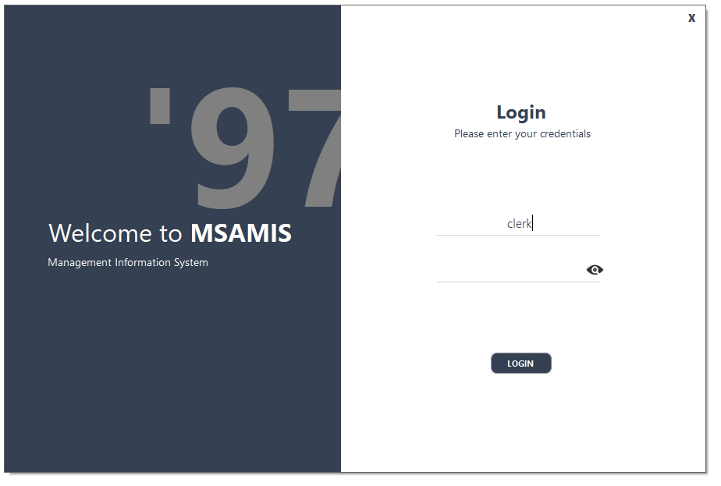

1. 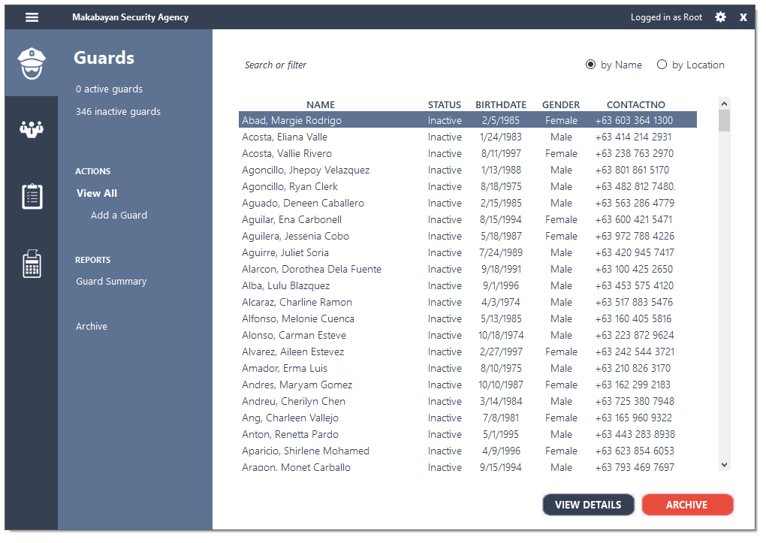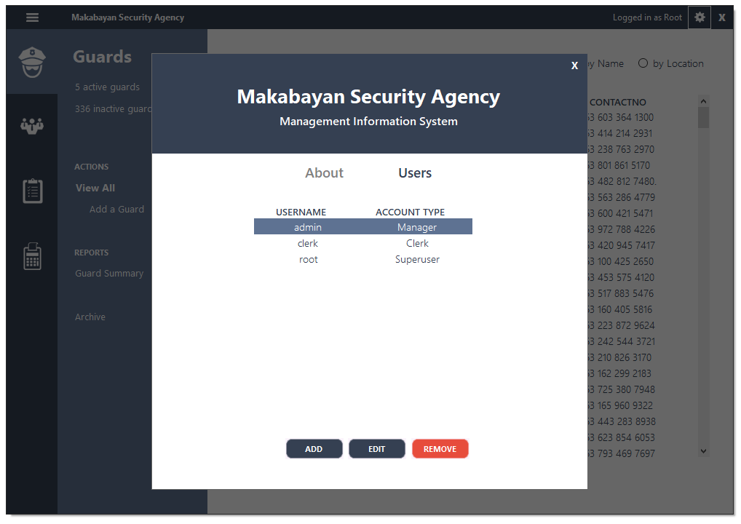Guards Management System

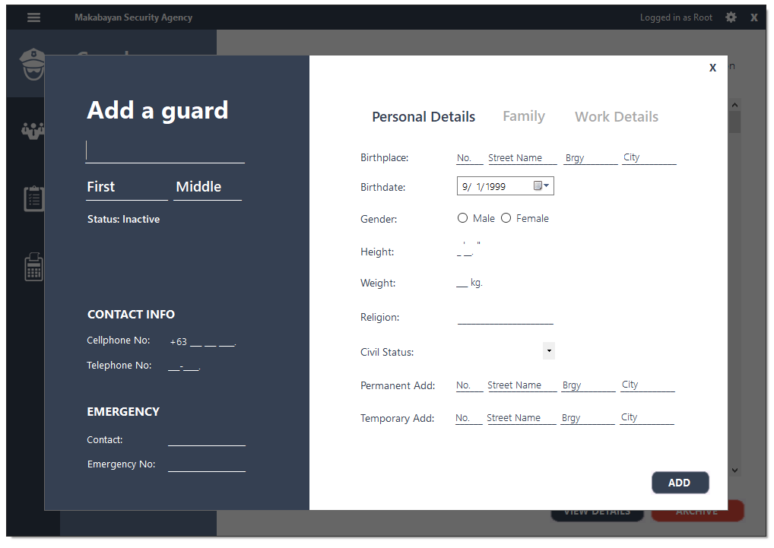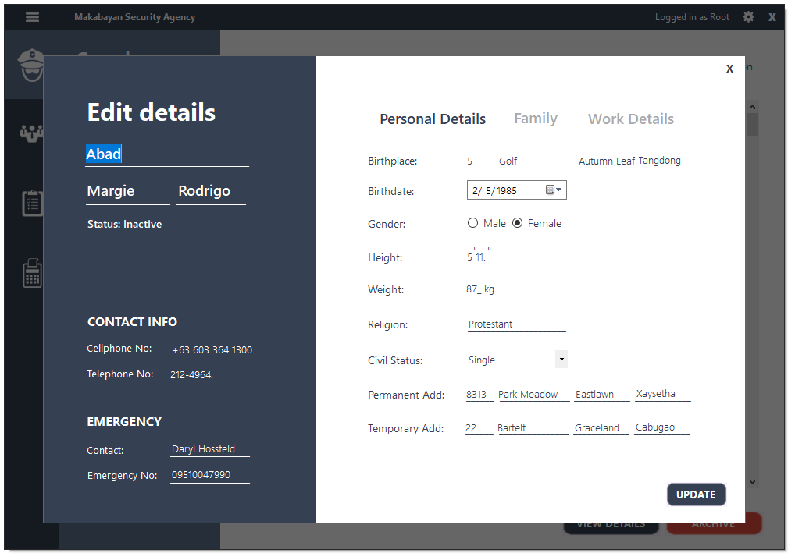

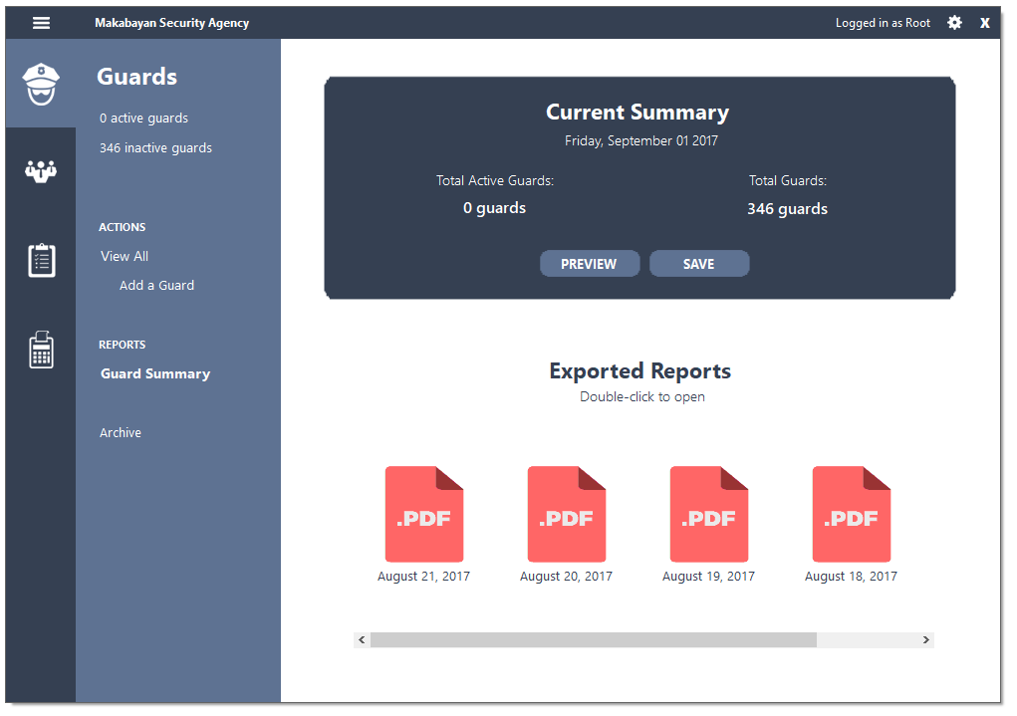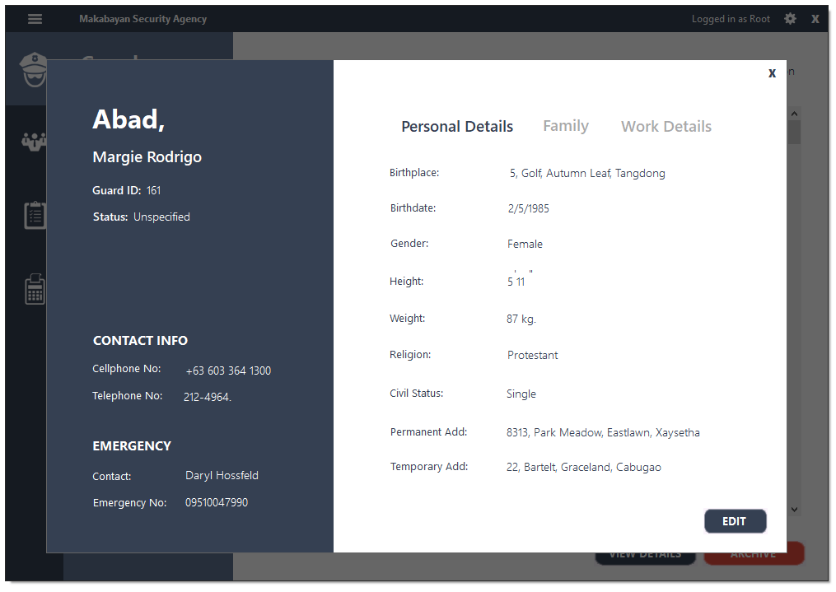

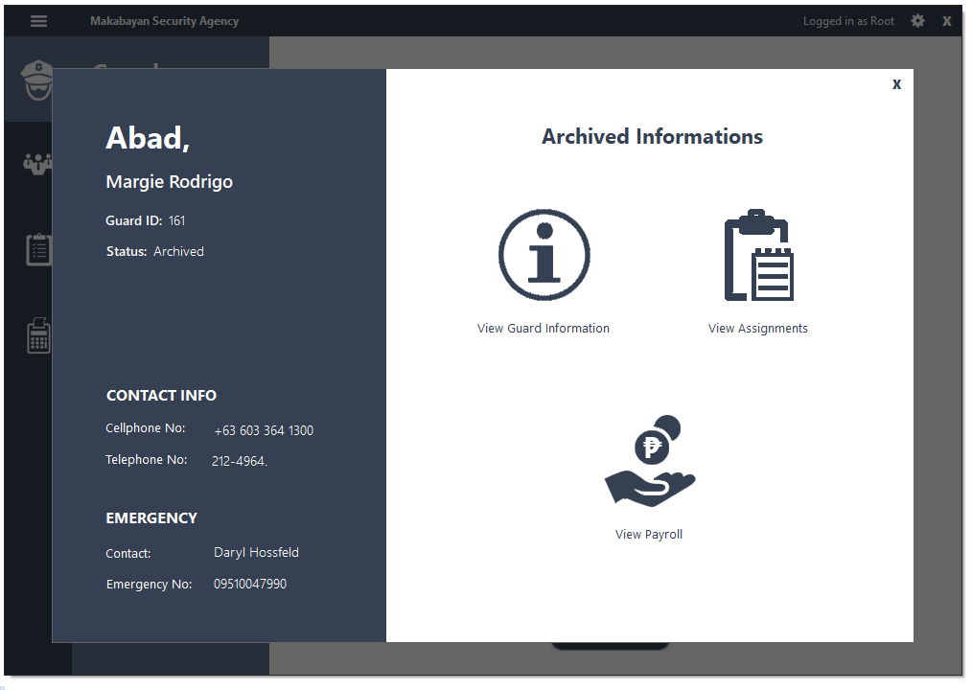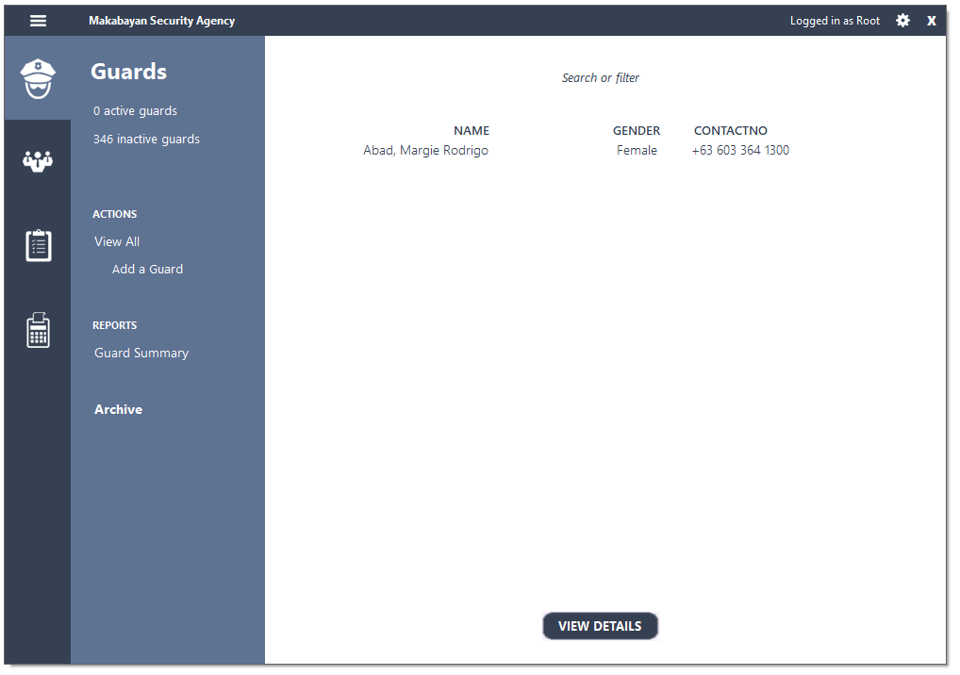

1. 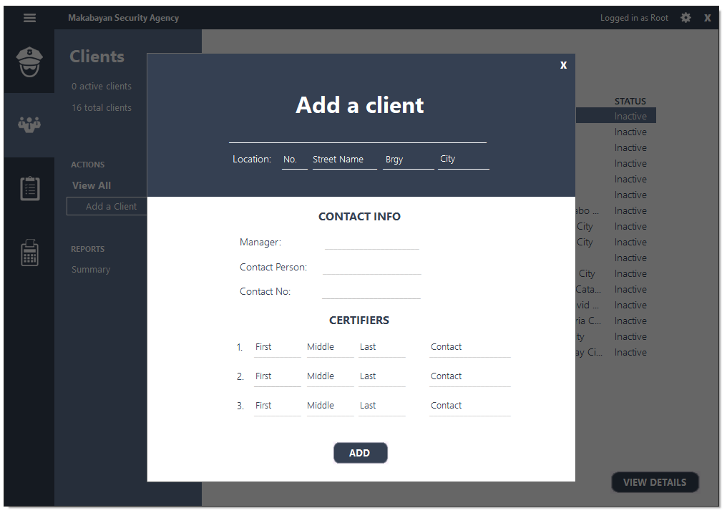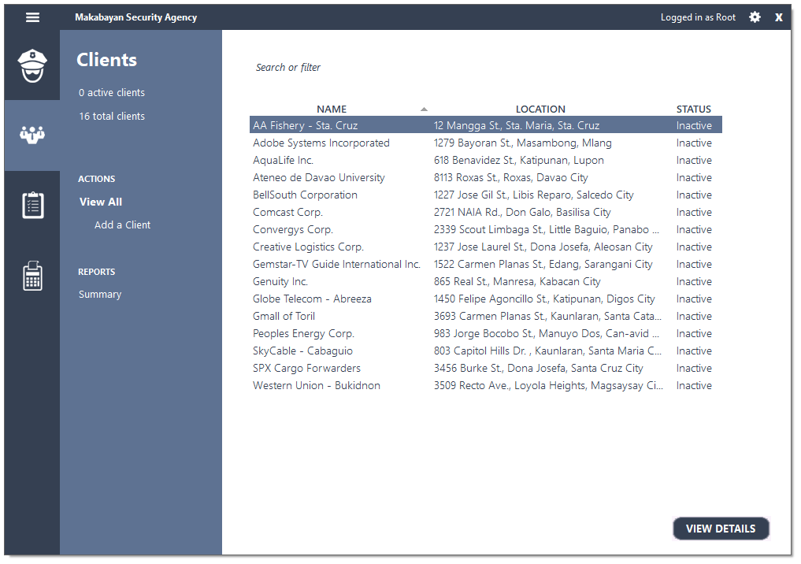Clients Management System

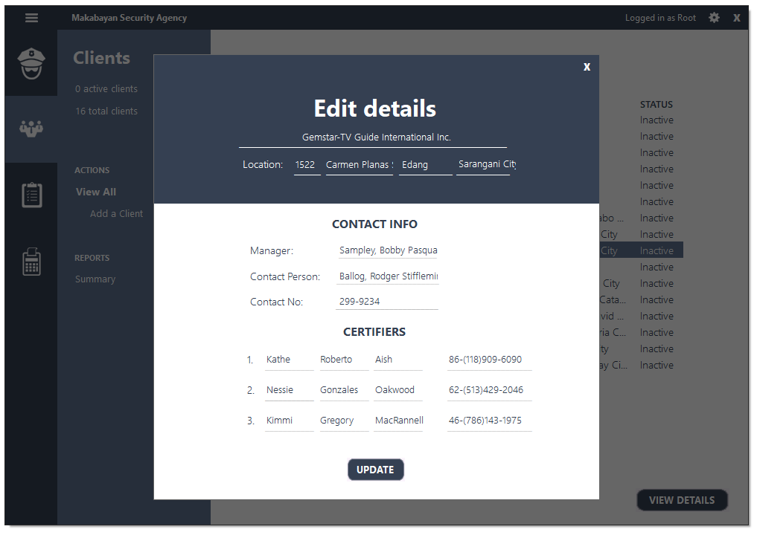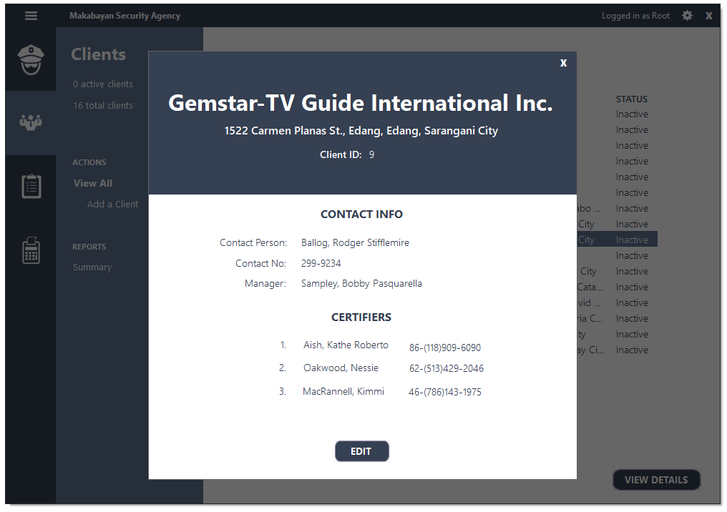

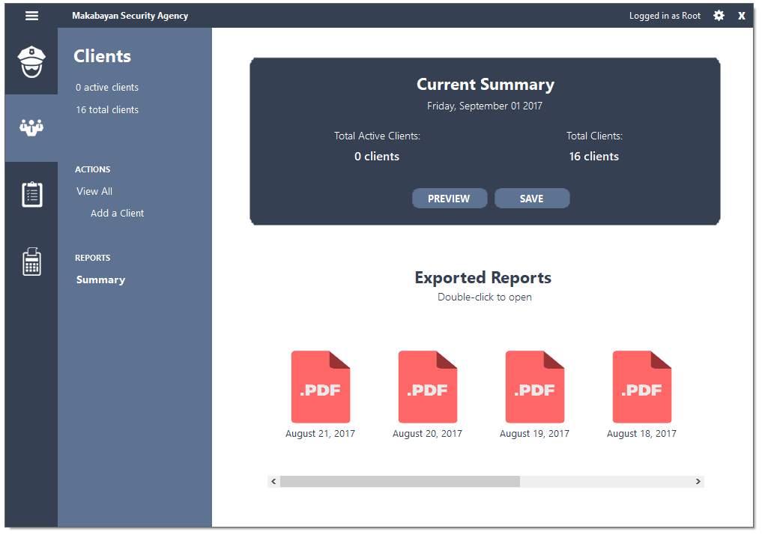

1. 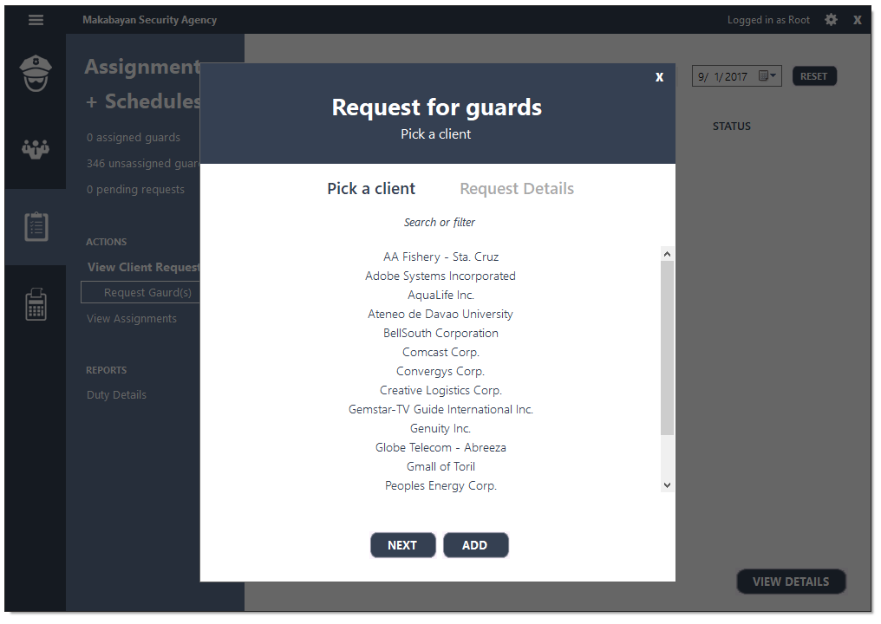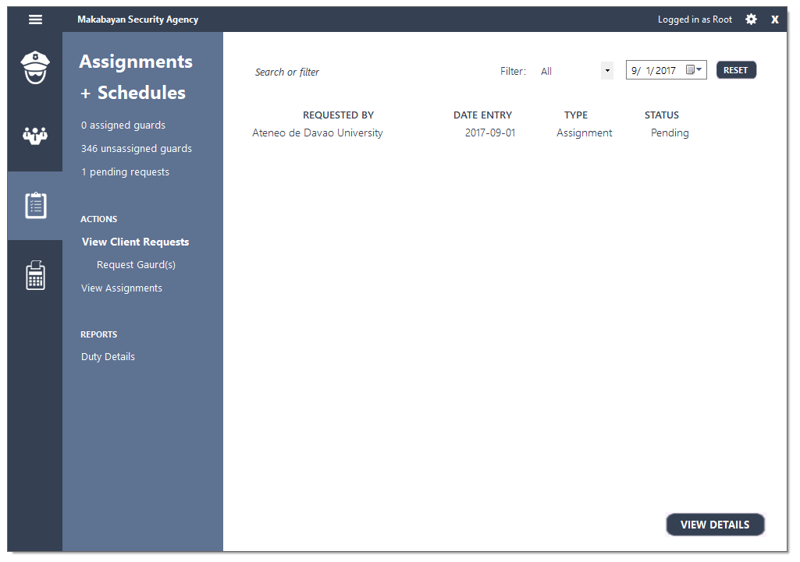Assignments and Guard Schedules Management System

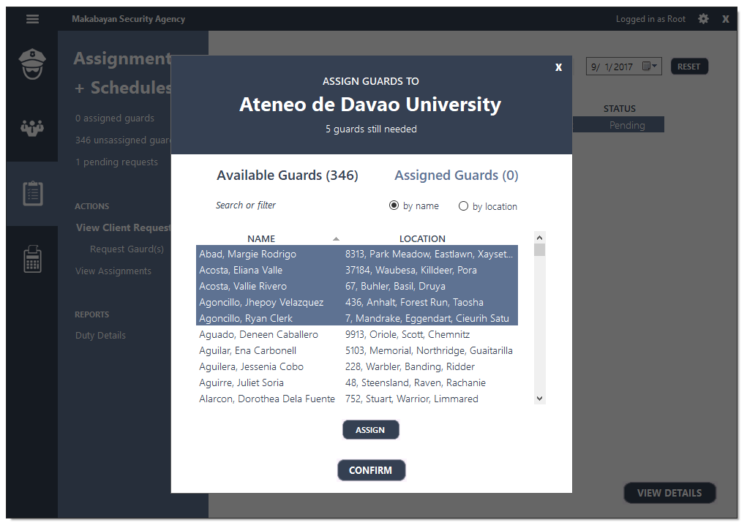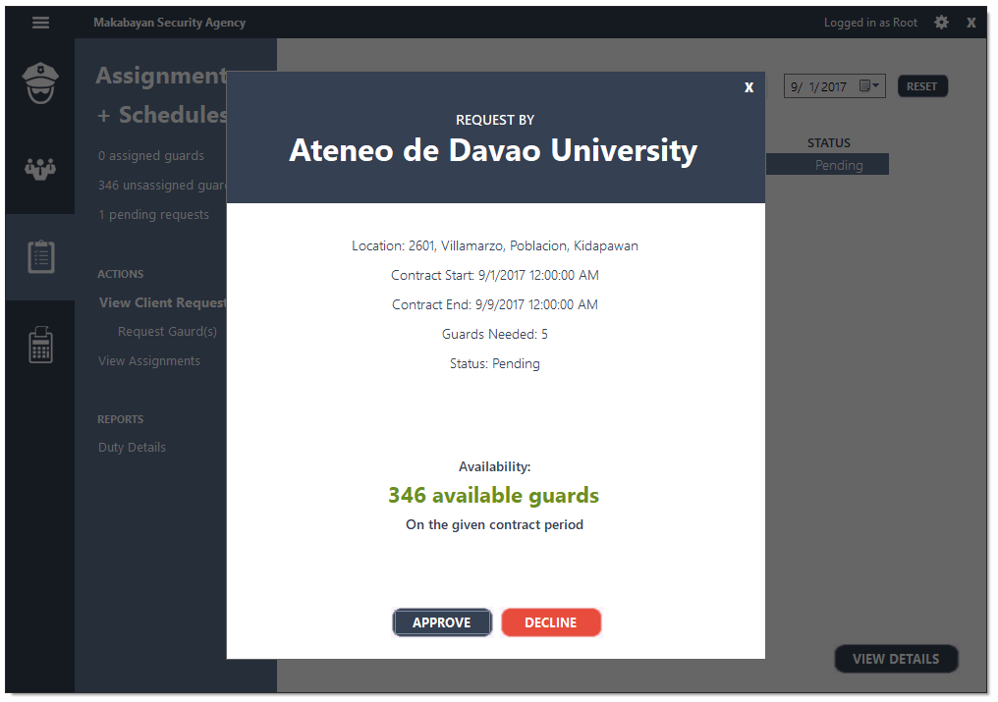

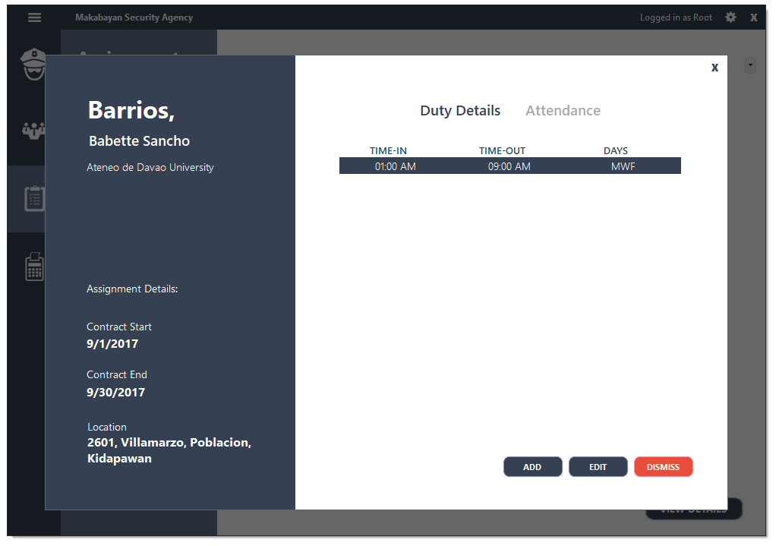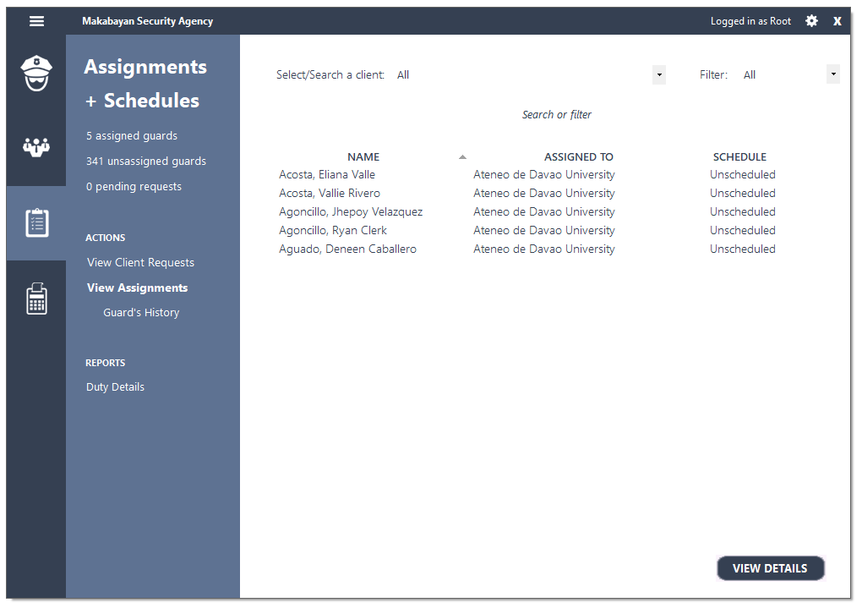

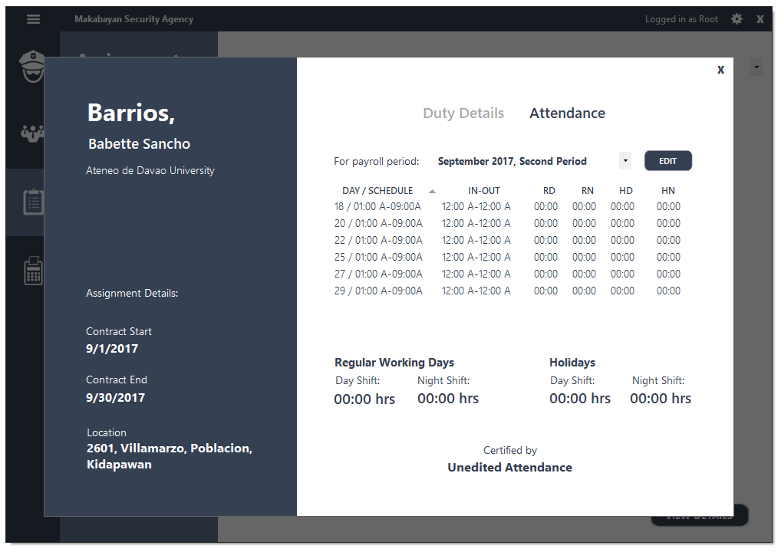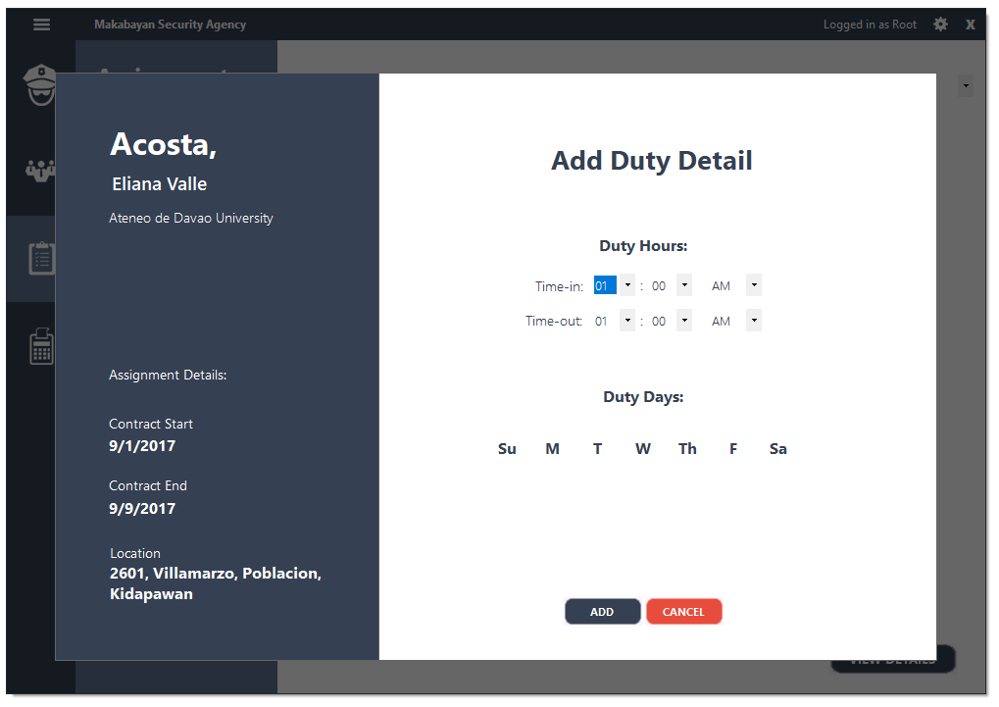

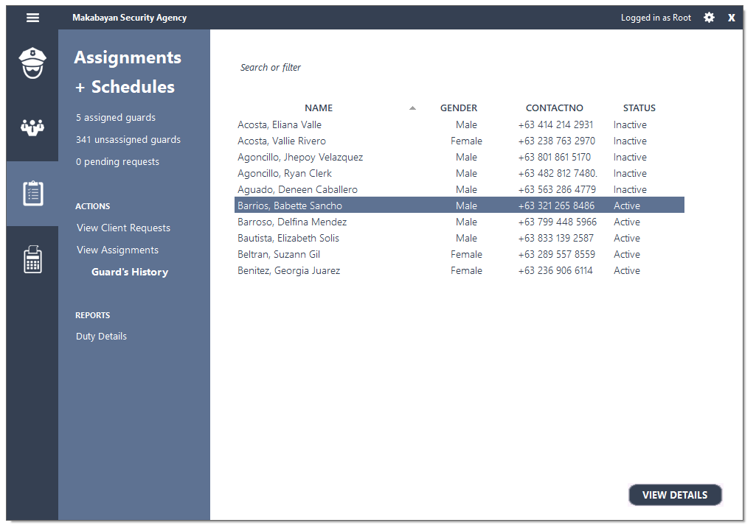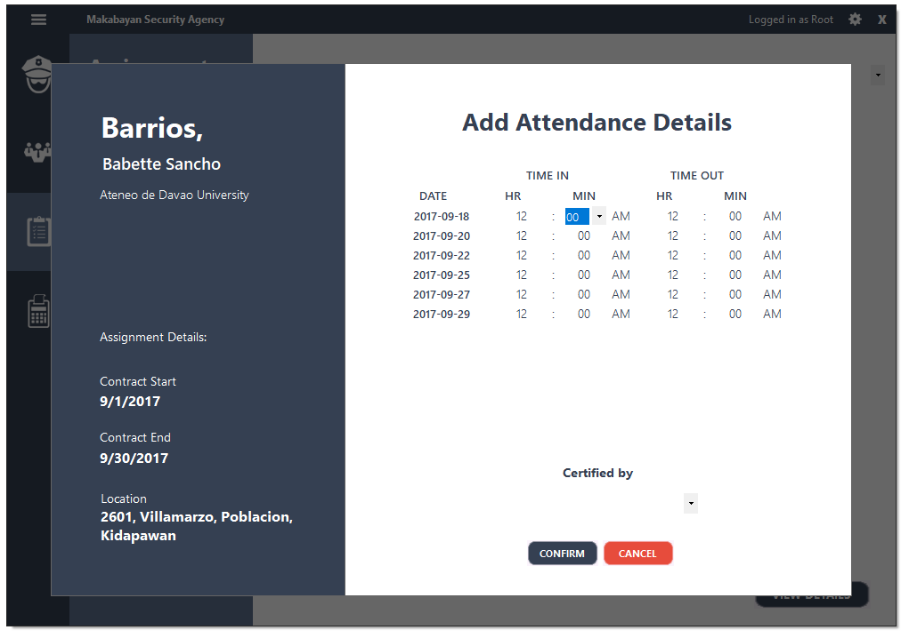

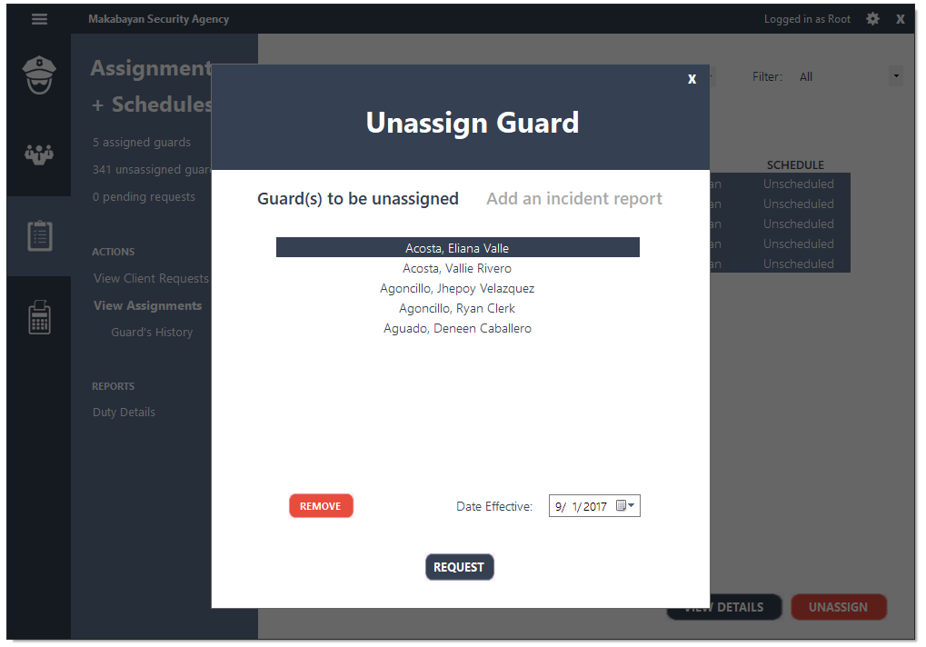

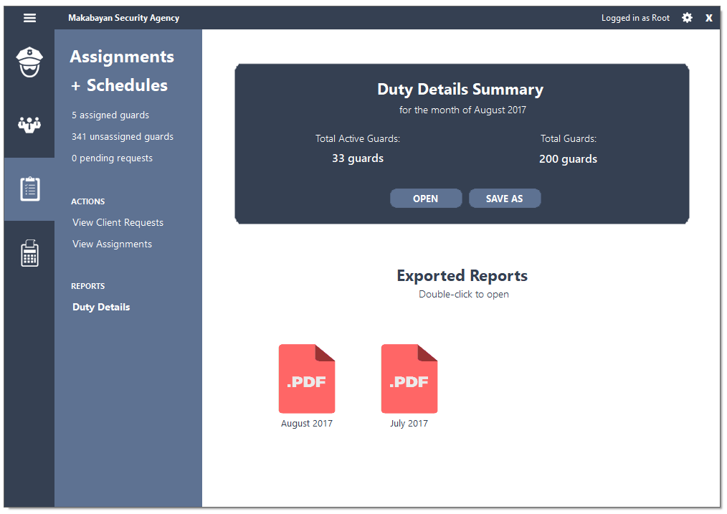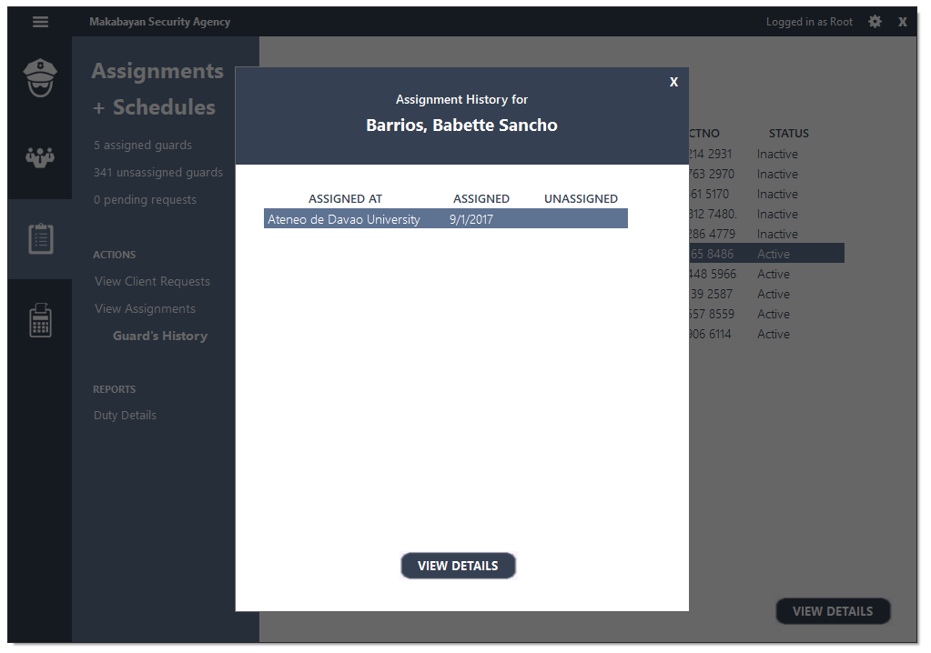

1. 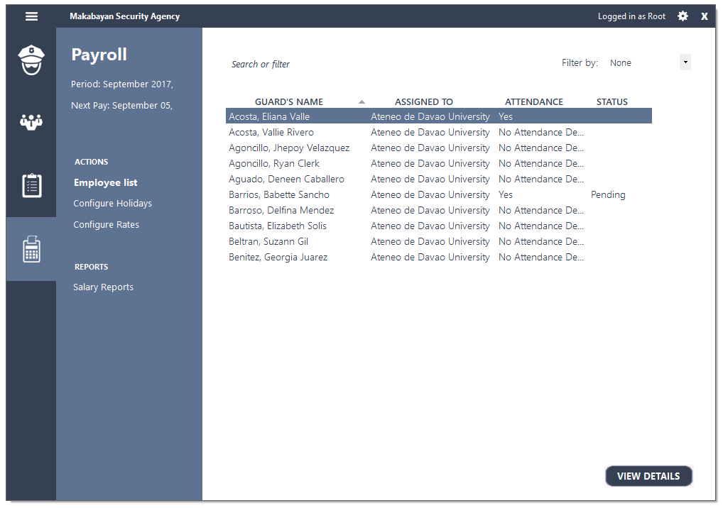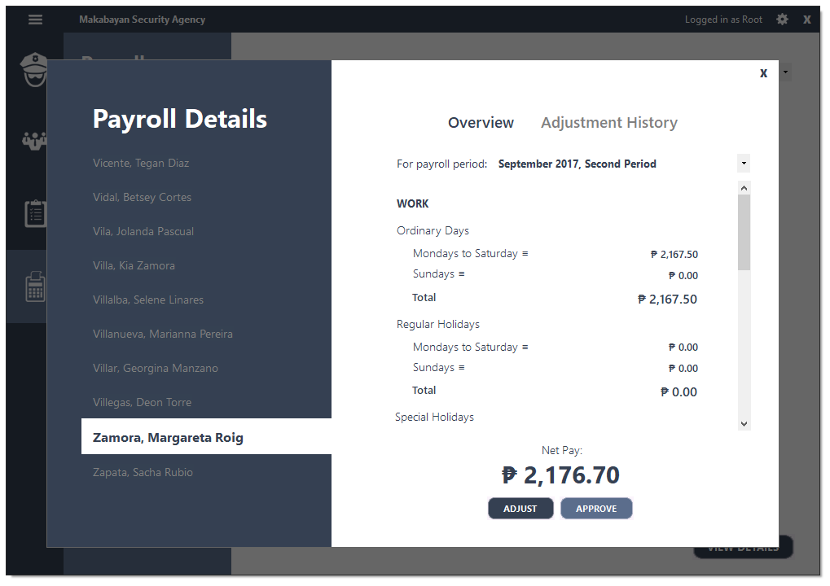Payroll Management System

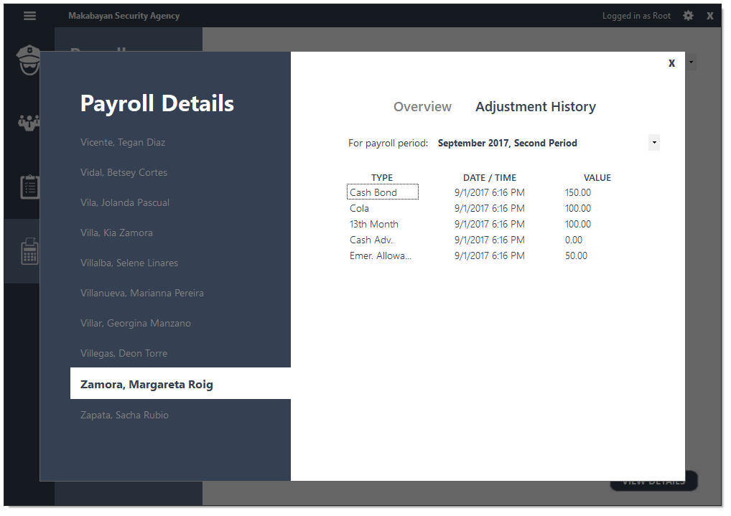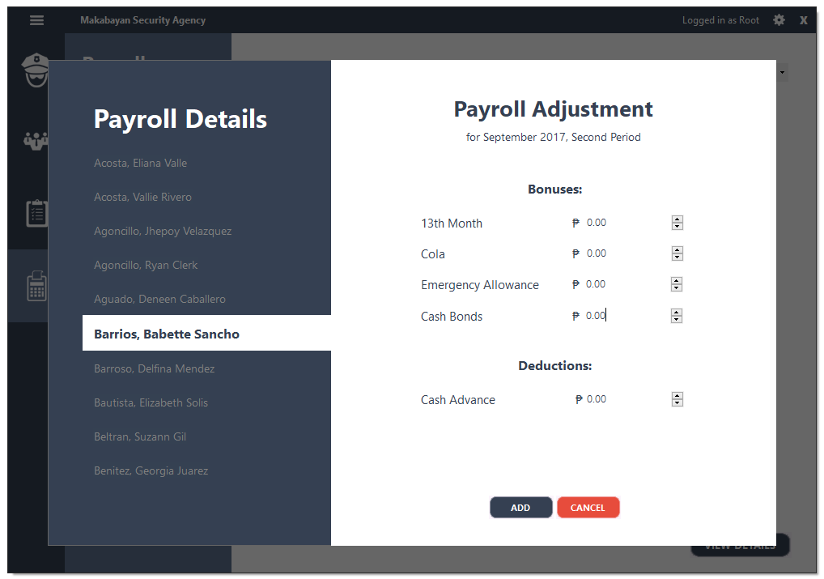

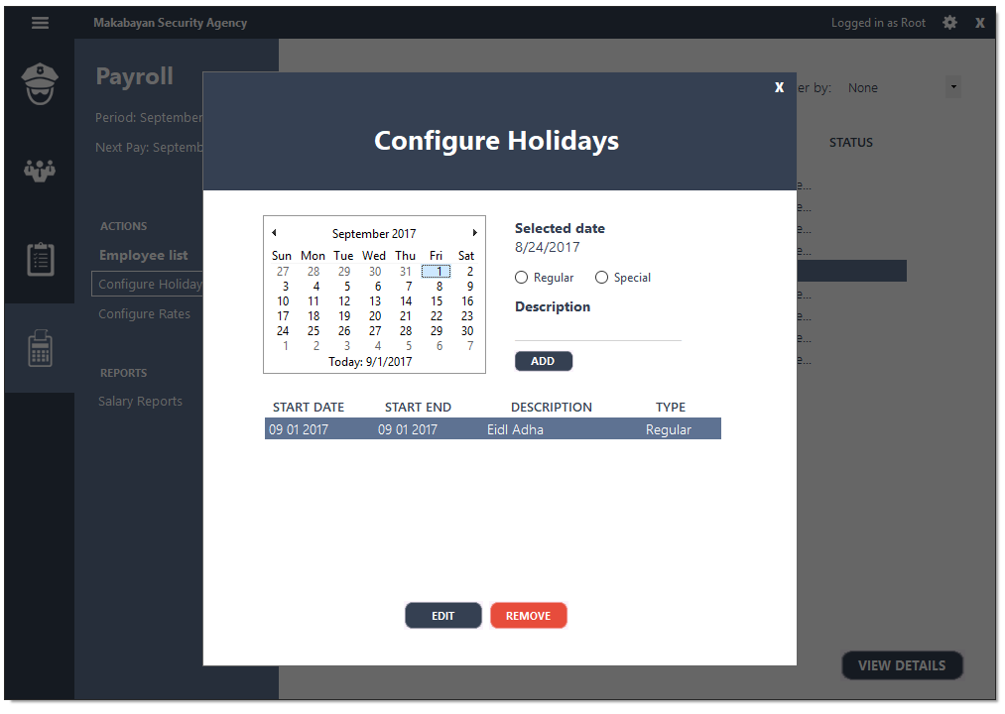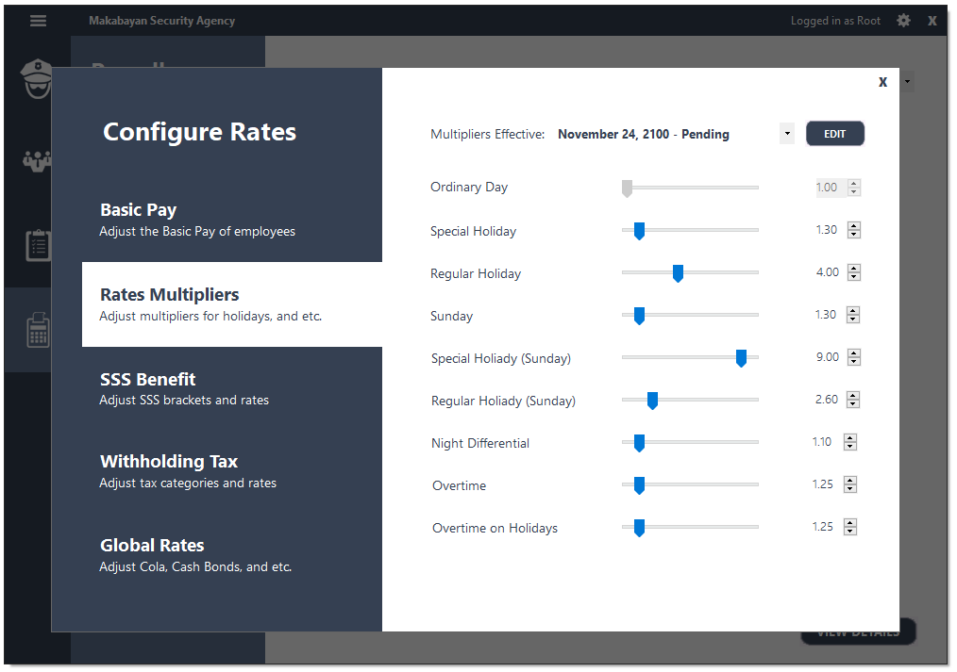

# **REFERENCES**

Laudon, K. C., & Laudon, J. P. (2009). Management Information Systems: Managing the Digital Firm. Prentice Hall/CourseSmart.

Makabayan Security Agency. (2016). *Agency Profile.* Davao City: Makabayan Security Agency.

Philippine Governement. (2016). *Implementing Rules and Regulations of Republic Act 10591.* Retrieved from Philippine Governement: http://www.gov.ph/2013/12/07/implementing-rules-and-regulations-of-republic-act-no-10591/

Small Business. (n.d.). *Administrative Functions Management Information System.* Retrieved from Small Business: http://smallbusiness.chron.com/administrative-functions-management-information-system-78916.html

**APPENDICES**

